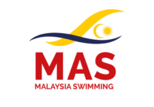 | 3rd MALAYSIA OPEN DIVING CHAMPIONSHIP 2025.  *World Aquatics Recognised Event*  31st October – 2nd November 2025 | 

TRAVEL INFORMATION FORM
(Please return by 1st October 2025)

1 | Country / Federation:
2 | Contact Person:
3 | Telephone Number:
4 | E-mail:

Arrival Details:
Arrival Date | Airline | Flight No. | Time | No. of Paxs

Departure Details:
Departure Date | Airline | Flight No. | Time | No. of Paxs

Return to: Mr Low Siak San, Andy
Tel No:- +603 8996 1755 Fax :- +603 8996 1758

Email: secgen@malaysiaaquatics.org

Date :-__________________ _____________________________ ______________
(PRESIDENT / SECRETARY GENERAL) FEDERATION STAMP

