

DIVING
POOL CERTIFICATION

ORGANIZING BODY
BUILDING NAME
OWNER
CONTRACTOR
DESIGN TEAM
DATE

WORLD AQUATICS
APPROVED BY
DATE
SIGNATURE

In force as from 1 April 2026

Table of Contents
DRAWING SUBMITTAL REQUIREMENTS 3
MEASUREMENT CRITERIA 3
TYPE OF VENUE 4
ORTHOGONALITY OF THE POOL 4
SPRINGBOARD DIVING 5
PLATFORM DIVING 7
GENERAL REQUIREMENTS 10
DIVING FACILITIES FOR OLYMPIC GAMES AND WORLD CHAMPIONSHIPS 18
ADDITIONAL COMMENTS 20
SIGNATURES 20

DRAWING SUBMITTAL REQUIREMENTS

As part of the facility pool certification document, the organizing body is required to submit drawings of the pool and associated competition areas for review in addendum with this document. These drawings must be in scale and reflect the as-built condition of the facility. The drawings must include:

A building plan view, including the FULL deck widths and spectator seating areas;

A pool plan view WITH CORRESPONDING WATER DEPTHS;

A POOL LONGITUDINAL SECTION VIEW WITH CORRESPONDING WATER DEPTHS;

And a POOL CROSS SECTION VIEW, showing SPRINGBOARD AND tower hEIghts, LOCATIONS AND WATER DEPTHS.

MEASUREMENT CRITERIA

The measurements must be done by a certified surveyor, appointed or approved by the Member in the country in which the venue is LOCATED.

The surveying equipment must be a Total Station. The minimum requirements of the Total Station are the following:
Angle Measurement Accuracy Horizontal and Vertical: 1" (0.3 mgon)
Distance Measurement Accuracy: 1mm + 1.5ppm.
The surveyor must provide a Calibration Certificate confirming the measurement quality of surveying equipment. The certificate MUST have a maximum validity of 1 year.
All dimensions must be measured using a mini prism or targets.
Diving tower measurements must be taken with the pool full of water.
Diving pool measurements must be taken with the pool EMPTY OF WATER.
The water temperature must not be less than 28 DEGREES CELCIUS PER PART 4, 15.2.12.1.

The horizontality of EACH platform edge must be measured IN at least in 3 points. A tolerance of 1MM per metre is allowed, providing that all the points are complying with CR 15.2.4 "The height of the springboards and each platform above the water level may vary by plus 0.05 metre and minus 0.00 metre from the heights prescribed in this Part Four. ".

TYPE OF VENUE

POOL CONSTRUCTION
(I.E. CONCRETE, STAINLESS STEEL, ETC.)
POOL FINISH
(I.E. PAINT, PLASTER, TILE, LINER, ETC.)

ORTHOGONALITY OF THE POOL

The sides of the pool must be orthogonal and form 90 degrees right angle. The tolerance of the angle is ±0.20º. The 2 diagonals must be the same length. The tolerance of the diagonal is 10mm.
ORTHOGONALITY OF THE POOL | MEASUREMENT
ANGLE 1 [º]
ANGLE 2 [º]
ANGLE 3 [º]
ANGLE 4 [º]
DIAGONAL 1 [M]
DIAGONAL 2 [M]

SPRINGBOARD DIVING

PART 4, 15.2 – Dimensions and design requirements for Diving facilities:
15.2.1 - The required dimensions for all Diving facilities detailed in Appendices 1 and 2 must be met.
15.2.1.1 - If possible, the preferred dimensions set out in Appendices 1 and 2 should be met.
15.2.1.2 - However, in all cases, the minimum dimensions set out in Appendices 1 and 2 must be met.
15.2.1.3 - It is permissible for facilities to have a combination of measurements which meet and/or exceed the minimum dimensions (as set out in Appendices 1 and 2).
PART 4, 15.3.2 - Springboards must be 4.88 metres long and 0.5 metre wide. Springboards must have a slip-resistant surface, which must be inspected and approved by World Aquatics prior to the start of the competition.
WORLD AQUATICS RULE | COMPLIANT | NONCOMPLIANT
PART 4, 15.3.2

PART 4, 15.3.3 - Springboards must be provided with movable fulcrums which can easily be adjusted by Athletes. In addition, for springboards at Diving facilities modified or constructed on concrete platforms after 1st October 2013, the following requirements apply:
15.3.3.1 - The vertical distance from the level of the platform which supports the fulcrum assembly, to the level of the top of the springboard, must be 0.35 metres.
15.3.3.2 - The distance from the front edge of the fulcrum assembly (which must be 0.741 metres in length) to the front edge of the supporting platform, must be a maximum of 0.44 metre. If that requirement is not met, then the fulcrum assembly and the rear hinge assembly must be moved forward so as to provide for a maximum of 0.44 metres from the front edge of the platform to the front of the fulcrum assembly.
15.3.3.3 - The concrete platform that supports the springboard must be aligned with the pool wall or project over the pool.
WORLD AQUATICS RULE | COMPLIANT | NONCOMPLIANT
PART 4, 15.3.3

PART 4, 15.3.4 - The minimum distance from the rear to the centre line of the fulcrum must be set in accordance with the recommendation or specification of the springboard manufacturer.
WORLD AQUATICS RULE | COMPLIANT | NONCOMPLIANT
PART 4, 15.3.4

PART 4, 15.3.5 - A pool must have at least two springboards installed at the same, 3 metre, height, to accommodate synchronised events. The springboards may be placed on either one or both sides of the platform. At least two springboards at the same (3 metre) height must be placed side by side and no objects may obstruct the visibility in any part of the dive between the Athletes (as shown in Appendix 1 and Appendix 2).
WORLD AQUATICS RULE | COMPLIANT | NONCOMPLIANT
PART 4, 15.3.5

PART 4, 15.3.6 - The springboards must be installed exactly level horizontally, so that their leading edges are exactly level no matter the position of the movable fulcrum.
WORLD AQUATICS RULE | COMPLIANT | NONCOMPLIANT
PART 4, 15.3.6

PART 4, 15.3.7 - The back of the 3 metre springboards must be surrounded (on three sides) by handrails with a minimum clearance of 1.0 metres between vertical pairs. The minimum height for those handrails is 1.0 metre, measured from the level of the springboard. Handrails must be accompanied by at least two horizontal crossbars placed outside the platform, or a solid transparent barrier (see Appendix 1).
WORLD AQUATICS RULE | COMPLIANT | NONCOMPLIANT
PART 4, 15.3.7

PLATFORM DIVING

PART 4, 15.4.2 - Each platform must be rigid and horizontal.
WORLD AQUATICS RULE | COMPLIANT | NONCOMPLIANT
PART 4, 15.4.2

PART 4, 15.4.3 - The minimum dimensions of the platform are:
PLATFORM | REQUIRED WIDTH | REQUIRED LENGTH | MEASURED WIDTH | MEASURED LENGTH
0.6M TO 1.0M | 1.00M  2.90M* | 5.00M
2.6M TO 3.0M | 1.00M  2.00M* | 5.00M
5.0M | 2.90M | 6.00M
7.5M | 2.00M | 6.00M
10.0M | 3.00M | 6.00M
*PREFERRED DIMENSION

PART 4, 15.4.6 - The thickness of the front edge of the platform must be between 0.2 and 0.3 metres and may be vertical or inclined at an angle no greater than 10 degrees to the vertical inside the plummet line.
WORLD AQUATICS RULE | COMPLIANT | NONCOMPLIANT
PART 4, 15.4.6

PART 4, 15.4.7 - The surface and the front edge of the platform must be covered throughout with a resilient slip-resistant material. The two surfaces must be covered separately in order to achieve a clean 90 degree angle or as described in Article 15.2.7 of this Part Four. The front surface should be applied first and then the top surface.
WORLD AQUATICS RULE | COMPLIANT | NONCOMPLIANT
PART 4, 15.4.7

PART 4, 15.4.8 - The platforms must be covered in a slip-resistant material that has a tread pattern that provides sufficient traction in wet and dry conditions such that the Athletes are prevented from slipping when performing dives in all directions. The minimum thickness of the slip-resistant material is 6mm and the colour must give a contrast to the surrounding décor. The material must be easily cleaned to maintain its slip-resistance.
WORLD AQUATICS RULE | COMPLIANT | NONCOMPLIANT
PART 4, 15.4.8

PART 4, 15.4.9 - The front edge of the 10 metre platform must project at least 1.50 metres beyond the edge of the pool. The 7.5 metre, 5 metre, and 2.6 – 3.0 metre platforms must project at least 1.25 metres beyond the edge of the pool. The 0.6 – 1-metre platform must project at least 0.75 metre beyond the edge of the pool.
WORLD AQUATICS RULE | COMPLIANT | NONCOMPLIANT
PART 4, 15.4.9

PART 4, 15.4.10 - It is preferable that a platform is not constructed directly under any other platform. However, in circumstances where this cannot be avoided or is already the case: where a platform is directly underneath another platform, the platform above must project a minimum of 0.75 metres (but preferably 1.25 metres) beyond the platform below; and the requirements in Appendix 1 and Appendix 2 must be met.
WORLD AQUATICS RULE | COMPLIANT | NONCOMPLIANT
PART 4, 15.4.10

PART 4, 15.4.11 - The back and sides of each platform (except the 1.0 metre or lower platforms) must be surrounded by handrails up to 1.0 metres from the front edge of the platform with a minimum clearance of 1.0 metres between vertical pairs. The minimum height must be 1.0 metre, and they must be accompanied by at least two horizontal crossbars, or a solid transparent barrier, placed outside the platform beginning 1.0 metre from the front edge of the platform.
WORLD AQUATICS RULE | COMPLIANT | NONCOMPLIANT
PART 4, 15.4.11

PART 4, 15.4.12 - Each platform must be accessible by suitable stairs (not ladders) as required by the country's building regulations and or health and safety standards that are applicable.
WORLD AQUATICS RULE | COMPLIANT | NONCOMPLIANT
PART 4, 15.4.12

PART 4, 15.4.13 - For platforms and the supporting structures of springboard, the minimum design load is p = 350 kiloponds (kilograms force) per lineal metre. In addition to that static requirement (and for the comfort and safety of the user with respect to the movement of the towers), the following limits must be observed, with respect to the platforms and springboard supports:
15.4.13.1 - Fundamental frequency of platforms: 10 Hz
PLATFORM | MINIMUM | MAXIMUM
10M | 10 HZ | 20 HZ
7.5M, 5M, 3M, 1M | 10 HZ | 30 HZ

15.4.13.2 - The minimum frequency of diving towers is 3.5 Hz. The permitted total oscillation of the whole tower structure is ± 2mm.
15.4.13.3 - The spatial deformation of the front edge of the platforms as a result of Px = Py = Pz = 100 kiloponds (kilograms force) must only be a maximum of 1 mm (see figure immediately below).
15.4.13.4 - These requirements can be met most adequately by a reinforced concrete structure. Proof of the frequencies measured (the dynamic behaviour) is to be obtained together with the static calculations for the whole structure.
 | YES | NO
STRUCTURAL REPORT ISSUED
WORLD AQUATICS RULE | COMPLIANT | NONCOMPLIANT
PART 4, 15.4.13

GENERAL REQUIREMENTS

PART 4, 15.1.2.1 - For diving facilities constructed after 1 January 2025, the pool should if possible have a minimum depth of 5 metres in the area of the pool under the springboards and platforms, but in any event must meet the minimum depth(s) set out for the relevant events, in accordance with Appendix 2.
PART 4, 15.1.2.2 - For diving facilities constructed after 26 September 2013, the minimum dimensions for diving facilities detailed in Appendix 1 and Appendix 2 must be met, using, as a basic measuring point of reference, the plummet line.
PART 4, 15.2.2 - The dimensions C from plummet to adjacent plummet in the tables of Appendices 1 and 2 apply to platforms with widths as detailed in Article 14.2.2 of Part Five. If platform widths are increased, then the dimensions B and C must be increased by half the additional widths.
PART 4, 15.2.1.3 - It is permissible for facilities to have a combination of measurements which meet and/or exceed the minimum dimensions (as set out in Appendices 1 and 2).
PART 4, 15.2.3 - The vertical height from the plummet of the platform and or springboard at rest to the water surface at rest (undisturbed, without sprays, bubbles, or motion) must be specified in a ‘diving facilities dimensions’ table for the pool. These measurements must be certified by a surveyor or other qualified officials, appointed or approved by or the Member Federation of the country in which the pool is situated.
WORLD AQUATICS RULE | COMPLIANT | NONCOMPLIANT
PART 4, 15.1.2.1
PART 4, 15.1.2.2
PART 4, 15.2.2
PART 4, 15.2.1.3
PART 4, 15.2.3

THE DIVING FACILITIES DIMENSION TABLES INCLUDED BELOW MUST BE COMPLETED TO VALIDATE WORLD AQUATICS COMPETITION REGULATIONS ARE MET. THE NATIONAL FEDERATION IS RESPONSIBLE FOR VERIFYING EACH DIMENSION IS COMPLIANT. PART 4, 17.1 APPENDIX 1 AND PART 4, 17.2 APPENDIX 2 ARE INCLUDED ON PAGE 11 AND 12, respectively, FOR REFERENCE.

PLATFORM OR SPRINGBOARD | MEASUREMENT
PLATFORM OR SPRINGBOARD | X0 [M] | X1 [M] | X2 [M]
S1 | - |  | -
S1 | - |  | -
S1 | - |  | -
P1
S3 | - |  | -
S3 | - |  | -
S3 | - |  | -
P3
P5
P7.5
P10
SPRINGBOARD AND PLAFORM DIVING HEIGHTS |  | COMPLIANT | NONCOMPLIANT

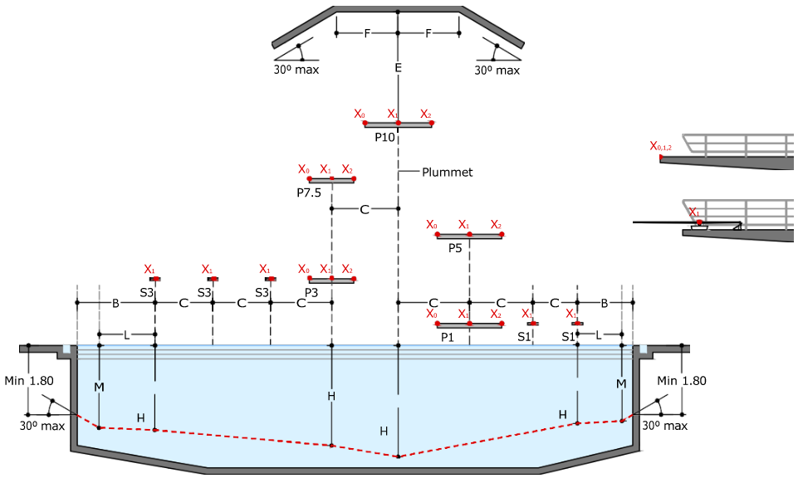
DIMENSION [M] | SPRINGBOARD
DIMENSION [M] | 1 METRE |  |  | 3 METRE
A - PLUMMET BACK TO POOL WALL
B - PLUMMET TO POOL WALL AT SIDE
C - PLUMMET TO ADJACENT PLUMMET
D - PLUMMET FORWARD TO POOL WALL
E - SPRINGBOARD TO CEILING OR PLATFORM ABOVE
F - CLEAR OVERHEAD SIDE
G - CLEAR OVERHEAD FORWARD
H - DEPTH OF WATER AT PLUMMET
J - DISTANCE AHEAD OF PLUMMET AT DEPTH K
K - DEPTH AHEAD OF PLUMMET AT DISTANCE J
L - DISTANCE TO SIDE OF PLUMMET AT DEPTH M
M - DEPTH TO SIDE OF PLUMMET AT DISTANCE L
N - MAXIMUM SLOPE TO REDUCE DIMENSIONS BEYOND FULL REQUIREMENT FOR THE POOL DEPTH AND CEILING HEIGHT
MAXIMUM LANDING ZONE WIDTH
HANDRAIL MEASUREMENTS  1 METRE | COMPLIANT |  |  |  | NONCOMPLIANT
HANDRAIL MEASUREMENTS  3 METRE | COMPLIANT |  |  |  | NONCOMPLIANT
SPRINGBOARD DIMESIONS | COMPLIANT |  |  |  | NONCOMPLIANT
*Space for 3 springboards at each height has been given. If more springboards are present, print additional tables to include all springboards.

DIMENSION [M] | PLATFORM
DIMENSION [M] | P-1 | P-3 | P-5 |  | P-7.5 | P-10
A - PLUMMET BACK TO POOL WALL
A/A - PLUMMET BACK TO PLATFORM
B - PLUMMET TO POOL WALL AT SIDE*
C - PLUMMET TO ADJACENT PLUMMET*
D - PLUMMET FORWARD TO POOL WALL
E - PLATFORM TO CEILING OR PLATFORM ABOVE
F - CLEAR OVERHEAD SIDE
G - CLEAR OVERHEAD FORWARD
H - DEPTH OF WATER AT PLUMMET
J - DISTANCE AHEAD OF PLUMMET AT DEPTH K
K - DEPTH AHEAD OF PLUMMET AT DISTANCE J
L - DISTANCE TO SIDE OF PLUMMET AT DEPTH M
M - DEPTH TO SIDE OF PLUMMET AT DISTANCE L
N - MAXIMUM SLOPE TO REDUCE DIMENSIONS BEYOND FULL REQUIREMENT FOR THE POOL DEPTH AND CEILING HEIGHT
MAXIMUM LANDING ZONE WIDTH
HANDRAIL MEASUREMENTS | COMPLIANT |  |  | NONCOMPLIANT
PLATFORM DIMESIONS | COMPLIANT |  |  | NONCOMPLIANT
*REFER TO PART 4, 15.2.2. IF platform widths are increased then the dimensions B and C must be increased by half the additional widths

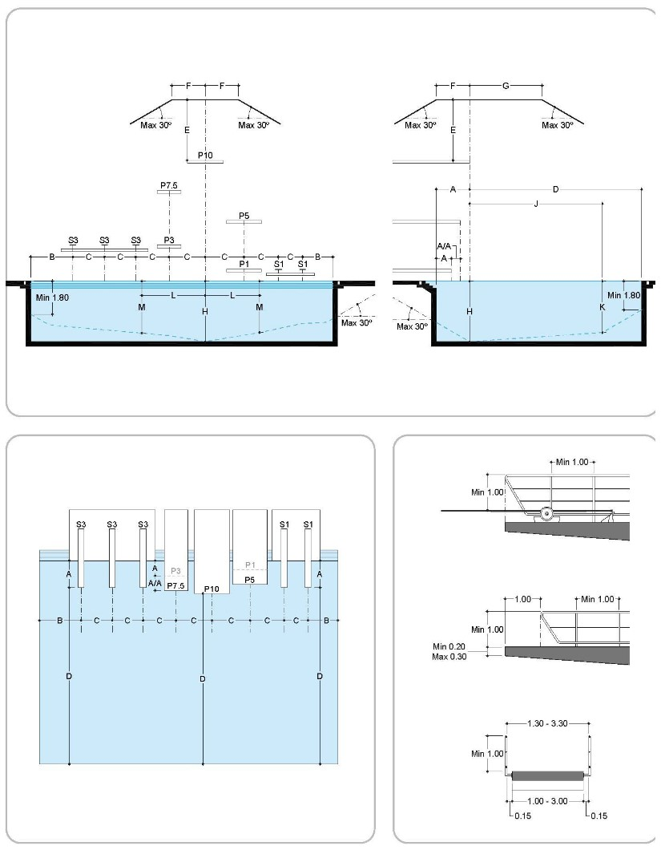
1. PART 4, 17.1 APPENDIX 1

Dimensions tor Diving Facilities |  |  | SPRINGBOARD |  |  |  | PLATFORM
 |  |  | 1 metre |  | 3 metres |  | 1 metre |  | 3 metres |  | 5 metres |  | 7.5 metres |  | 10 metres
 |  | Length | 4.88 |  | 4.88 |  | 5.00 |  | 5.00 |  | 6.00 |  | 6.00 |  | 6.00
 |  | Width | 0.50 |  | 0.50 |  | 1.00 min.  2.90 pref. |  | 1.00 min.  2.00 pref. |  | 2.90 |  | 2.00 |  | 3.00
 |  | Height | 1.00 |  | 3.00 |  | 0.60 min.  1.00 pref. |  | 2.60 min.  3.00 pref. |  | 5.00 |  | 7.50 |  | 10.00
 |  |  | Horiz | Vert | Horiz | Vert | Horiz | Vert | Horiz | Vert | Horiz | Vert | Horiz | Vert | Horiz | Vert
A | From plummet back to pool wall platform edge for Concrete Platform | Designation | A-1 |  | A-3 |  | A-1P |  | A-3P |  | A-5 |  | A-7.5 |  | A-10
A |  | Minimum | 2.22 |  | 2.22 |  | 0.75 |  | 1.25 |  | 1.25 |  | 1.25 |  | 1.50
A |  | Preferred | 2.22 |  | 2.22 |  | 0.75 |  | 1.25 |  | 1.25 |  | 1.25 |  | 1.50
A | From plummet back to pool wall for Pedestals and Metal Stands
A |  | Minimum | 1.50 |  | 1.50
A |  | Preferred | 1.83 |  | 1.83
A/A | From plummet  Back to Platform Plummet directly below | Designation |  |  |  |  |  |  |  |  | A/A 5/1 |  | A/A 7.5/3, 1 |  | A/A 10/5, 3, 1
A/A | From plummet  Back to Platform Plummet directly below | Minimum |  |  |  |  |  |  |  |  | 0.75 |  | 0.75 |  | 0.75
A/A | From plummet  Back to Platform Plummet directly below | Preferred |  |  |  |  |  |  |  |  | 1.25 |  | 1.25 |  | 1.25
B | From plummet to Pool Wall at Side | Designation | B-1 |  | B-3 |  | B-1P |  | B-3P |  | B-5 |  | B-7.5 |  | B-10
B | From plummet to Pool Wall at Side | Minimum | 2.50 |  | 3.50 |  | 2.50 |  | 3.00 |  | 4.00 |  | 4.50 |  | 5.75
B | From plummet to Pool Wall at Side | Preferred | 2.50 |  | 3.50 |  | 2.50 |  | 3.60 |  | 4.50 |  | 4.75 |  | 5.75
C | From plummet to Adjacent Plummet | Designation | C1-1 |  | C3-3, 3-1 |  | C1-1P |  | C3-3P, 1P |  | C5-3, 5-1 |  | C7.5-5, 3, 1 |  | C10-7.5, 5, 3, 1
C | From plummet to Adjacent Plummet | Minimum | 2.00 |  | 2.20 |  | 1.85 |  | 2.20* |  | 2.85* |  | 2.75* |  | 3.00*
C | From plummet to Adjacent Plummet | Preferred | 2.00 |  | 2.60 |  | 2.15 |  | 2.35* |  | 2.85* |  | 2.75* |  | 3.00*
D | From plummet to Minimum Pool Wall Ahead | Designation | D-1 |  | D-3 |  | D-1P |  | D-3P |  | D-5 |  | D-7.5 |  | D-10
D | From plummet to Minimum Pool Wall Ahead | Minimum | 9.00 |  | 10.25 |  | 8.00 |  | 9.50 |  | 10.25 |  | 11.00 |  | 13.50
D | From plummet to Minimum Pool Wall Ahead | Preferred | 9.00 |  | 10.25 |  | 8.00 |  | 9.50 |  | 10.25 |  | 11.00 |  | 13.50
E | On plummet from Board to Ceiling | Designation |  | E-1 |  | E-3 |  | E-1P |  | E-3P |  | E-5 |  | E-7.5 |  | E-10
E | On plummet from Board to Ceiling | Minimum |  | 5.00 |  | 5.00 |  | 3.25 |  | 3.25 |  | 3.25 |  | 3.25 |  | 4.00
E | On plummet from Board to Ceiling | Preferred |  | 5.00 |  | 5.00 |  | 3.50 |  | 3.50 |  | 3.50 |  | 3.50 |  | 5.00
F | Clear Overhead behind and each side of plummet | Designation | F-1 | E-1 | F-3 | E-3 | F-1P | E-1P | F-3P | E-3P | F-5 | E-5 | F-7.5 | E-7.5 | F-10 | E-10
F | Clear Overhead behind and each side of plummet | Minimum | 2.50 | 5.00 | 2.50 | 5.00 | 2.75 | 3.25 | 2.75 | 3.25 | 2.75 | 3.25 | 2.75 | 3.25 | 2.75 | 4.00
F | Clear Overhead behind and each side of plummet | Preferred | 2.50 | 5.00 | 2.50 | 5.00 | 2.75 | 3.50 | 2.75 | 3.50 | 2.75 | 3.50 | 2.75 | 3.50 | 2.75 | 5.00
G | Clear Overhead ahead of plummet | Designation | G-1 | E-1 | G-3 | E-3 | G-1P | E-1P | G-3P | E-3P | G-5 | E-5 | G-7.5 | E-7.5 | G-10 | E-10
G | Clear Overhead ahead of plummet | Minimum | 5.00 | 5.00 | 5.00 | 5.00 | 5.00 | 3.25 | 5.00 | 3.25 | 5.00 | 3.25 | 5.00 | 3.25 | 5.00 | 4.00
G | Clear Overhead ahead of plummet | Preferred | 5.00 | 5.00 | 5.00 | 5.00 | 5.00 | 3.50 | 5.00 | 3.50 | 5.00 | 3.50 | 5.00 | 3.50 | 5.00 | 5.00
H | Depth of Water at plummet | Designation |  | H-1 |  | H-3 |  | H-1P |  | H-3P |  | H-5 |  | H-7.5 |  | H-10
H | Depth of Water at plummet | Minimum |  | 3.40 |  | 3.70 |  | 3.20 |  | 3.50 |  | 3.70 |  | 4.10 |  | 4.50
H | Depth of Water at plummet | Preferred |  | 5.00 |  | 5.00 |  | 5.00 |  | 5.00 |  | 5.00 |  | 5.00 |  | 5.00
J  K | Distance and Depth ahead of plummet for all stands | Designation | J-1 | K-1 | J-3 | K-3 | J-1P | K-1P | J-3P | K-3P | J-5 | K-5 | J-7.5 | K-7.5 | J-10 | K-10
J  K | Distance and Depth ahead of plummet for all stands | Minimum | 5.00 | 3.30 | 6.00 | 3.60 | 4.50 | 3.10 | 5.50 | 3.40 | 6.00 | 3.60 | 8.00 | 4.00 | 11.00 | 4.25
J  K | Distance and Depth ahead of plummet for all stands | Preferred | 5.00 | 3.40 | 6.00 | 3.70 | 4.50 | 3.20 | 5.50 | 3.50 | 6.00 | 3.70 | 8.00 | 4.40 | 11.00 | 4.75
L  M | Distance and Depth each side of plummet | Designation | L-1 | M-1 | L-3 | M-3 | L-1P | M-1P | L-3P | M-3P | L-5 | M-5 | L-7.5 | M-7.5 | L-10 | M-10
L  M | Distance and Depth each side of plummet | Minimum | 1.50 | 3.40 | 2.00 | 3.70 | 1.40 | 3.20 | 1.80 | 3.50 | 3.00 | 3.70 | 3.75 | 4.40 | 4.50 | 5.00
L  M | Distance and Depth each side of plummet | Preferred | 2.00 | 3.50 | 2.50 | 4.10 | 1.90 | 4.00 | 2.30 | 4.10 | 3.50 | 4.00 | 4.50 | 4.70 | 5.25 | 5.25
N | Maximum slope to reduce dimensions beyond full requirement for pool depth and ceiling height = 30 Degrees

2. PART 4, 17.2 APPENDIX 2

PART 4, 15.2.4 - The height of the springboards and each platform above the water level may vary by plus 0.05 metre and minus 0.00 metre from the heights prescribed in this Part Four.
WORLD AQUATICS RULE | COMPLIANT | NONCOMPLIANT
PART 4, 15.2.4

PART 4, 15.2.5 - The end of 5, 3, and 1 metre platforms must not project beyond the ends of the 3 and 1 metre springboards when they are adjacent to each other.
WORLD AQUATICS RULE | COMPLIANT | NONCOMPLIANT
PART 4, 15.2.5

PART 4, 15.1.3 - In the area of full water depth (as prescribed in Articles 15.1.2 to 15.1.4 of this Part Four), the bottom of the pool may rise by 2%. In any case, the depth of water in the Diving pool must not be less than 1.8 metres at any point.
WORLD AQUATICS RULE | COMPLIANT | NONCOMPLIANT
PART 4, 15.1.3

PART 4, 15.2.6 - In outdoor pools, where possible (best practice provides that) springboards and platforms should face north in the northern hemisphere and south in the southern hemisphere.
WORLD AQUATICS RULE | COMPLIANT | NONCOMPLIANT | N/A
PART 4, 15.2.6

PART 4, 15.2.7 - Pool walls must be vertical and form 90-degree (right) angles to the surface of the water. They must be constructed of solid material, with a slip-resistant surface.
WORLD AQUATICS RULE | COMPLIANT | NONCOMPLIANT
PART 4, 15.2.7

PART 4, 15.2.8 - The admissible tolerance in a wall’s verticality will be ± 0.3 degrees.
WORLD AQUATICS RULE | COMPLIANT | NONCOMPLIANT
PART 4, 15.2.8

PART 4, 15.2.9 - Rest ledges along the pool walls are permitted; they must be not less than 1.2 metres below the water’s surface and may be 0.1 metres to 0.15 metres wide. Only internal rest ledges are permitted.
WORLD AQUATICS RULE | COMPLIANT | NONCOMPLIANT
PART 4, 15.2.9

PART 4, 15.2.10 - Mechanical surface agitation must be installed under the diving facilities to aid the Athletes in their visual perception of the surface of the water. A horizontal water sprinkler system must be used for this purpose.
WORLD AQUATICS RULE | COMPLIANT | NONCOMPLIANT
PART 4, 15.2.10

PART 4, 15.2.11.2 - At other Diving events held under these Competition Regulations, the minimum illumination at a level of 1 metre above the water surface must not be less than 600 lux throughout the pool.
 | YES | NO
LIGHTING REPORT ISSUED
WORLD AQUATICS RULE | COMPLIANT | NONCOMPLIANT
PART 4, 15.2.11.2

PART 4, 15.2.11.3 - Sources of natural and artificial illumination must be provided with controls to prevent glare.
WORLD AQUATICS RULE | COMPLIANT | NONCOMPLIANT
PART 4, 15.2.11.3

PART 4, 15.2.12.1 - The water temperature must be not less than 28 degrees Celsius.
WORLD AQUATICS RULE | COMPLIANT | NONCOMPLIANT
PART 4, 15.2.12.1

DIVING FACILITIES FOR OLYMPIC GAMES AND WORLD CHAMPIONSHIPS

PART 4, 1.6 - All Diving facilities and equipment at World Aquatics Events and the Olympic Games, including springboards, platforms and dryland equipment, must comply with the requirements in Article 15 of this Part Four and be inspected and approved by World Aquatics no later than 120 days prior to the start of the competition in accordance with Article 15 of this Part Four.
WORLD AQUATICS RULE | COMPLIANT | NONCOMPLIANT | N/A
PART 4, 1.6

PART 4, 15.6.2.1 - The light intensity at the level of 1m above the water surface must not be less than 1500 lux.
WORLD AQUATICS RULE | COMPLIANT | NONCOMPLIANT | N/A
PART 4, 15.6.2.1

PART 4, 15.6.3.1 - Lane markings for the Diving pool will consist of 3 lines running the width of the diving well 90-degree angle to the Athlete facing forward on the springboard or platform, with the same dimensions set out in Article 15 of Part Two. These lines must be prepared as follows:
15.6.3.1.1 - The distance between the centre points of each lane must be 2.5 metres.
15.6.3.1.2 - The centre of the first line must be directly under the plummet of the 3 metre springboard (see Appendix 3).
WORLD AQUATICS RULE | COMPLIANT | NONCOMPLIANT | N/A
PART 4, 15.6.3.1

PART 4, 15.6.5.1 - If the Diving pool and the Swimming pool are in the same competition area, the minimum distance separating the pools must be at least 8 metres, however 10 metres is preferred (see Article 16.2.17 of Part Two).
WORLD AQUATICS RULE | COMPLIANT | NONCOMPLIANT | N/A
PART 4, 15.6.5.1

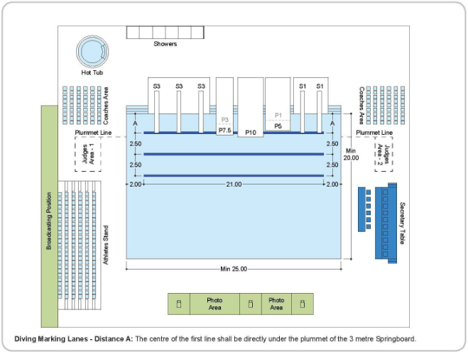

ADDITONAL COMMENTS

This section is provided for additional comments:

SIGNATURES

BUILDING NAME
SURVEYOR |  | SIGNATURE
SURVEYOR |  | DATE
POOL OPERATOR |  | SIGNATURE
POOL OPERATOR |  | DATE
ORGANIZING BODY |  | SIGNATURE
ORGANIZING BODY |  | DATE
FEDERATION |  | SIGNATURE
FEDERATION |  | DATE
REVIEW STAMP

