

SWIMMING
Pool CERTIFICATION

ORGANIZING BODY
BUILDING NAME
OWNER
CONTRACTOR
DESIGN TEAM
DATE

WORLD AQUATICS
APPROVED BY
DATE
SIGNATURE

In force as from 1 APRIL 2026

Table of Contents
DRAWING SUBMITTAL REQUIREMENTS 3
MEASUREMENT CRITERIA 3
TYPE OF VENUE 4
ORTHOGONALITY OF THE POOL 4
LENGTH AND DIMENSIONAL TOLERANCES - 50M POOL WITH NO BULKHEAD 5
LENGTH AND DIMENSIONAL TOLERANCES - 50M POOL WITH BULKHEAD 6
LENGTH AND DIMENSIONAL TOLERANCES - 25M POOL WITH BULKHEAD 7
POOL WIDTH 8
POOL DEPTH 10
WALLS 11
POOL LANES 13
POOL LANE ROPES 15
STARTING PLATFORMS 20
BACKSTROKE EQUIPMENT 23
WATER CONDITIONS 25
LIGHTING 26
LANE MARKINGS 27
BULKHEADS 28
POOL SEPARATION 29
TIMING REQUIREMENTS 30
ADDITONAL COMMENTS 32
SIGNATURES 32

DRAWING SUBMITTAL REQUIREMENTS

As part of the pool certification document, the organizing body is required to submit drawings of the pool and associated competition areas for review in addendum with this document. These drawings must be in scale and reflect the as-built condition of the facility. The drawings must include:

A building plan view, including the FULL deck widths and spectator seating areas;

A pool plan view WITH CORRESPONDING WATER DEPTHS;

A POOL LONGITUDINAL SECTION VIEW WITH CORRESPONDING WATER DEPTHS;

A POOL CROSS SECTION VIEW WITH CORRESPONDING WATER DEPTHS.

THE MANUFACTURERS CUT SHEET FOR THE STARTING BLOCKS

MEASUREMENT CRITERIA

THE MEASUREMENTS SHALL BE DONE BY A CERTIFIED SURVEYOR, APPOINTED OR APPROVED BY THE MEMBER IN THE COUNTRY IN WHICH THE VENUE IS LOCATED.

The surveying equipment shall be a Total Station. The minimum requirements of the Total Station are the following:
Angle Measurement Accuracy HORIzONTAL and VERTICAL: 1" (0.3 mgon)
Distance Measurement Accuracy: 1mm + 1.5ppm

The surveyor shall provide a Calibration Certificate confirming the measurement quality of surveying equipment. The certificate SHALL have a maximum validity of 1 year.

All dimensions shall be measured using a mini prism or targets.
The measurements corresponding to PART 2, 15.1, 15.2, AND 15.11 shall be measured with the pool full of water. The water level can be lowered up to 5cm FROM THE MEASUREMENT POINT to avoid water reflection when measuring.

The measurements corresponding to PART 2, 15.3, 15.4, 15.5, 15.6, 15.7, 15.8, 15.9, 15.10, 15.12, 15.13, 15.14, AND 15.15 shall be measured with the pool empty.
The water temperature shall be 25º TO 28º Centigrade.
the length of the pool IN PART 2, 15.1 & 15.2 shall be measured in the centre of each lane WITHOUT Automatic Officiating Equipment INSTALLED.
The width of the pool IN PART 2, 15.3 shall be measured at both ends.
The depth of the pool IN PART 2, 15.4 shall be measured at least in 3 points per lane: 1m from each end wall and in the centre of the pool.
The verticality of the end walls IN PART 2, 15.5 shall be measured in the centre of each lane. The end walls shall be vertical and form 90 degrees right angles. The admissible tolerance in walls verticality will be ±0.30º.

TYPE OF VENUE

POOL CONSTRUCTION
(I.E. CONCRETE, STAINLESS STEEL, ETC.)
POOL FINISH
(I.E. PAINT, PLASTER, TILE, LINER, ETC.)

ORTHOGONALITY OF THE POOL

The sides of the pool shall be orthogonal and form 90 degrees right angles. The tolerance of the angle is ±0.05º. The 2 diagonals shall be the same length. The tolerance of the diagonal is 10mm.
ORTHOGONALITY OF THE POOL | MEASUREMENT
ANGLE 1 [º]
ANGLE 2 [º]
ANGLE 3 [º]
ANGLE 4 [º]
DIAGONAL 1 [M]
DIAGONAL 2 [M]

LENGTH AND DIMENSIONAL TOLERANCES - 50M POOL WITH NO BULKHEAD

This section shall apply to 50m pools with no bulkhead. For other pool types, please use the corresponding page.
PART 2, 15.1.1.1 - If touch panels of Automatic Officiating Equipment are used at the starting end and/or at the turning end, the pool must be of such length that ensures the required distance of 50.000 metres between the two panels.
PART 2, 15.2.1.1 - The admissible tolerance in length in 50.000 metre swimming pools will be: +0.010 metres and -0.000 metres, when touch panels are installed.
PART 2, 15.2.1.2 - For pools with touch panels of Automatic Officiating Equipment on both ends, the wall to wall distance will be at minimum 50.020 metres and at maximum 50.030 metres.
PART 2, 15.2.1.3 - The required length, subject to the permitted tolerances, must be consistent from 0.300 metre above to 0.800 metre below the water surface.
Distances between walls - Length shall be measured in the centre of the lane.
LANE NUMBER | 1.1A [M] | 1.1B [M]
0
1
2
3
4
5
6
7
8
9

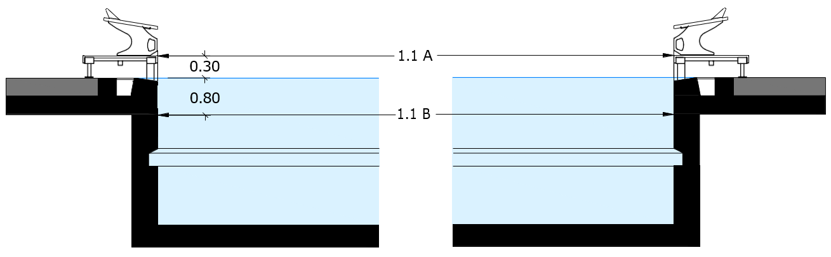

LENGTH AND DIMENSIONAL TOLERANCES - 50M POOL WITH BULKHEAD

This section shall apply to 50m pools with a bulkhead. For other pool types, please use the corresponding page.
PART 2, 15.1.1.1 - If touch panels of Automatic Officiating Equipment are used at the starting end and/or at the turning end, the pool must be of such length that ensures the required distance of 50.000 metres between the two panels.
PART 2, 15.2.1.1 - The admissible tolerance in length in 50.000 metre swimming pools will be: +0.010 metres and -0.000 metres, when touch panels are installed.
PART 2, 15.2.1.2 - For pools with touch panels of Automatic Officiating Equipment on both ends, the wall to wall distance will be at minimum 50.020 metres and at maximum 50.030 metres.
PART 2, 15.2.1.3 - The required length, subject to the permitted tolerances, must be consistent from 0.300 metre above to 0.800 metre below the water surface.
Distances between walls - Length shall be measured in the centre of the lane.
LANE NUMBER | 2.1A [M] | 2.1B [M]
0
1
2
3
4
5
6
7
8
9

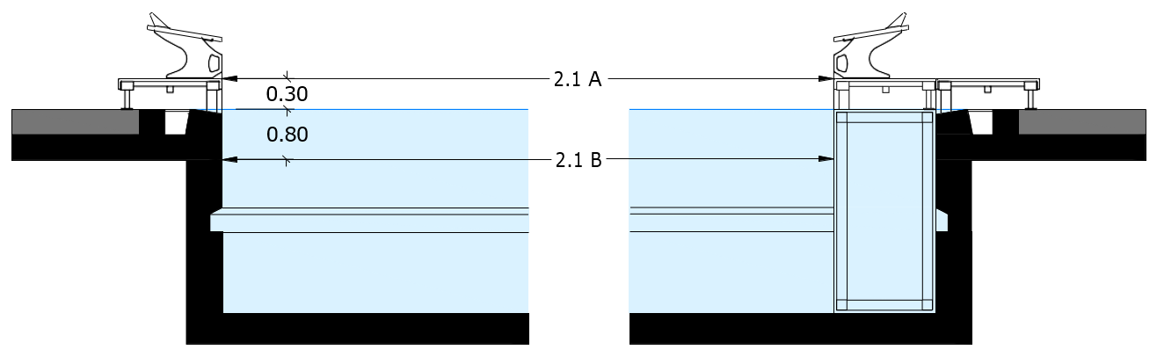

LENGTH AND DIMENSIONAL TOLERANCES - 25M POOL WITH BULKHEAD

This section shall apply to 25m pools with a bulkhead. For other pool types, please use the corresponding page.
PART 2, 15.1.2.1 - If touch panels of Automatic Officiating Equipment are used at the starting end and/or at the turning end, the pool must be of such length that ensures the required distance of 25.000 metres between the two panels.
PART 2, 15.2.2.1 - The admissible tolerance in 25.000 m swimming pools will be +0.010, and -0.000 metre when touch panels are installed.
PART 2, 15.2.2.2 - For pools with touch panels of Automatic Officiating Equipment on both ends the wall to wall distance will be at minimum 25.020 metres and at maximum 25.030 metres.
PART 2, 15.2.2.3 - For pools with touch panels of Automatic Officiating Equipment on one end the wall to wall distance will be at minimum 25.010 metres and at maximum 25.020 metres.
PART 2, 15.2.2.4 - The required length, subject to the permitted tolerances, must be consistent from 0.300 metre above to 0.800 metre below the water surface.
Distances between walls - Length shall be measured in the centre of the lane.
LANE NUMBER | 3.1A [M] | 3.1B [M] | 3.1C [M] | 3.1D [M]
0
1
2
3
4
5
6
7
8
9

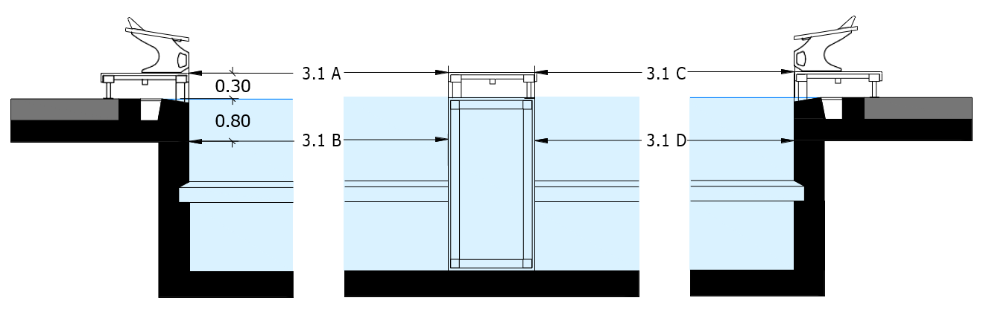

POOL WIDTH

PART 2, 15.3.1 - At the Olympic Games and the World Aquatics Championships, the minimum pool width for a permanent swimming pool is 25.000 metres and the minimum pool width for a temporary swimming pool is 26.000 metres.
PART 2, 15.3.2 - At all other competitions, there is no minimum width requirement.
WIDTH | MEASUREMENT [M]
END WALL 1
END WALL 2

POOL DEPTH

PART 2, 15.4.1 - At the Olympic Games and the World Aquatics Championships, the minimum pool depth is 2.5 metres.
PART 2, 15.4.2 - At the World Aquatics Swimming Championships (25m), the minimum pool depth is 2.0 metres (although 2.5 metres is recommended).
PART 2, 15.4.3 - At all other World Aquatics Events, the minimum pool depth is 1.0 metres, except that where starting blocks are used, the pool must have a minimum depth of 1.35 metres from between 1.0 metre from the end wall to at least 6.0 metres from the end wall.
LANE | WATER DEPTH - 1M FROM END WALL 1 [M] | WATER DEPTH - CENTER [M] |  | WATER DEPTH - 1M FROM END WALL 2 [M]
0
1
2
3
4
5
6
7
8
9
MINIMUM POOL DEPTH [M]
POOL LENGTH [M]
POOL USE CASE
(I.E OLYMPIC GAMES, WORLD CHAMPIONSHIPS, MULTISPORT)

POOL WALLS

PART 2, 15.5.1 - End walls must be vertical, parallel to each other, and form 90-degree right angles to the swimming course and to the surface of the water. They must be constructed of solid material, with a slip-resistant surface extending at least 0.8 metre below the water surface, so as to enable the competitor to touch and push off when turning without hazard. The admissible tolerance in walls verticality will be ±0.3 degrees.
LANE NUMBER | 0 | 1 | 2 | 3 | 4 | 5 | 6 | 7 | 8 | 9
ANGLE β - END WALL 1
ANGLE β - END WALL 2

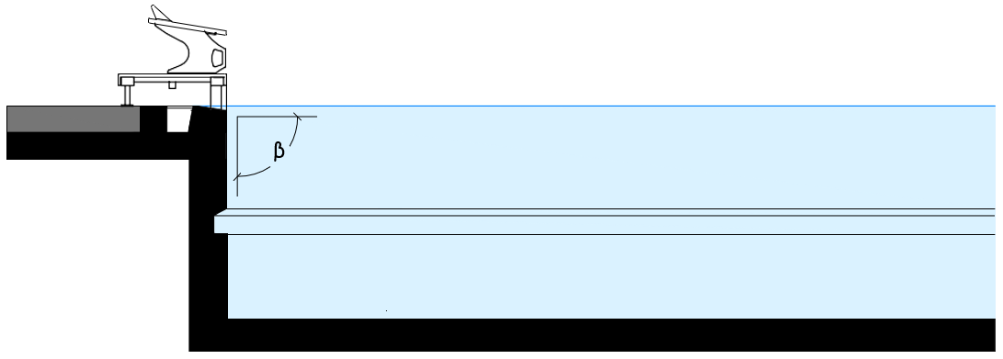
PART 2, 15.5.2 - Rest ledges along the pool walls are permitted. They must be located not less than 1.2 metres below the water surface, and may be 0.1 metre to 0.15 metre wide. Both internal and external ledges are permitted, but internal ledges are preferrable.
PART 2, 15.5.3 - Gutters may be placed on all four walls of the pool. If end wall gutters are installed, they must allow for attachment of touch panels to the required 0.3 metre above the water surface. Gutters must be covered with a suitable grill or screen.
WORLD AQUATICS RULE | YES | NO | N/A
REST LEDGES COMPLIANT WITH
PART 2, 15.5.2
GUTTERS COMPLIANT WITH
PART 2, 15.5.3

POOL LANES

PART 2, 15.6.1 - At the Olympic Games, the pool must contain eight (8) lanes that are 2.5 metres in width, with a gap – separated by lane ropes – of 2.5 metres in width at the outer side of the first lane and the outer side of the last lane. See the diagram at Appendix 1. Ninth and tenth lanes may be used in exceptional circumstances with the approval of the Chair of the Technical Swimming Committee.
PART 2, 15.6.2 - At the World Aquatics Championships and the World Aquatics Swimming Championships (25m), the pool must contain ten (10) lanes
PART 2, 15.6.2.1 - For a permanent swimming pool, the middle eight (8) lanes must be 2.5 metres in width, and the outer two lanes must be 2.4 metres in width with a gap – separated by lane ropes – of at least 0.1 metres in width at the outer side of the first lane and the outer side of the last lane. See the diagrams at Appendix 2 and Appendix 8.
PART 2, 15.6.2.2 - For a temporary swimming pool, the ten (10) lanes must be 2.5 metres in width with a gap – separated by lane ropes – of at least 0.5 metres in width at the outer side of the first lane and the outer side of the last lane. See the diagrams at Appendix 3 and Appendix 9.
PART 2, 15.6.3 - At all other competitions, there is no minimum number of lanes. Lanes must be at least 2.5 metres wide, except for the first and last lanes, which must be at least 2.4 metres wide with a gap of at least 0.1 metres in width at the outer side of the first lane and the outer side of the last lane.
WORLD AQUATICS RULE | COMPLIANT | NONCOMPLIANT |  | N/A
PART 2, 15.6.1
PART 2, 15.6.2
PART 2, 15.6.3
NUMBER OF LANES
TYPE OF POOL | PERMANENT |  | TEMPORARY

POOL LANE ROPES

PART 2, 15.7.3 - Lane ropes should be secured at each end wall to an anchor bracket recessed into the end wall. If anchor placement is on the pool deck, a firm and non-elastic extender must be in place. The installed lane rope should stay in the pool water. The anchor, including extender, must not extend more than 10mm into the pool. The anchor must not increase the length of the lane rope by more than ± 10mm each end of rope.
PART 2, 15.7.4 - The anchor must be positioned so that the wave reducing components at each end wall of the pool are 50% below the surface of the water. Anchors must be installed to withstand 20 kN of tensile force. Each lane rope will consist of wave reducing components placed end-to-end having a diameter of between 0.1 metres (at maximum) and 0.15 metres (at minimum). The design of discs and floats should be such that the floats, by themselves, do not influence the length of the lane rope. A float should be an integral part in between two discs. Throughout the length of the course, the lane rope must have a negative buoyancy so that at least one half to at most two thirds of the height of the wave reducing components are beneath the water surface.
WORLD AQUATICS RULE | COMPLIANT | NONCOMPLIANT
PART 2, 15.7.3
PART 2, 15.7.4

STARTING PLATFORMS

PART 2, 15.8.1 - Starting platforms will be firm and provide no springing effect. The height of the top of the platform above the water surface will be between 0.5 metres and 0.75 metres. The starting platform surface area will be at least 0.5 metres by 0.5 metres, and will be covered with a slip-resistant material.
PART 2, 15.8.2 - The maximum permitted slope of the starting platform will be 10 degrees. The starting platform may have an adjustable setting back plate. The platform will be constructed so as to permit the gripping of the platform by the Athlete in the forward start at the front and the sides; it is recommended that, if the thickness of the starting platform exceeds 0.04 metres, grips of at least 0.1 metre in width on each side and at least 0.4 metres in width in the front be cut out to 0.03 metre from the surface of the platform.
PART 2, 15.8.3 - Handgrips for the forward start may be installed on the sides of the starting platforms. Handgrips for Backstroke starts will be placed between 0.3 metres and 0.6 metres above the water surface both horizontally and vertically. They will be parallel to the surface of the end wall and must not protrude beyond the end wall.
PART 2, 15.8.4 - A minimum depth of 1.35 metres, extending from 1.0 metre from the end wall to at least 6.0 metres from the end wall is required for pools with starting blocks.
PART 2, 15.8.5 - Electronic display boards may be installed under the blocks, but the display must not flash and the figures must not move during a Backstroke start.
PART 2, 15.8.6 - Each starting platform must be distinctly numbered on all four (4) sides, and the numbers must be clearly visible. It is recommended that lane number zero (0) be on the right-hand side when facing the course from the starting end, with exception of 50m events, which may start from the opposite end. Touch panels may be numbered on the top or bottom part.
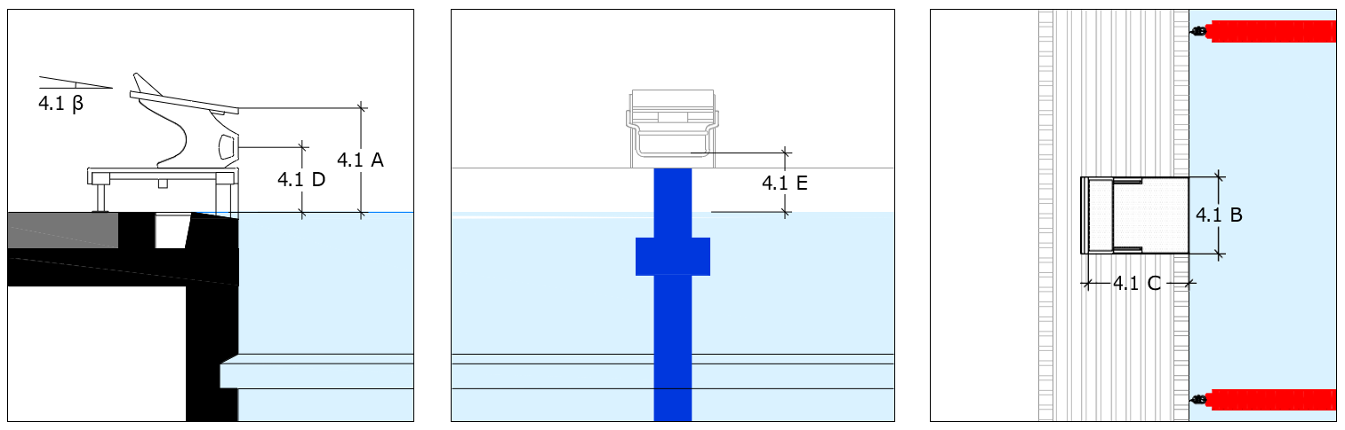
STARTING BLOCK DIMENSIONS | 4.1 A | 4.1 B | 4.1 C | 4.1 D | 4.1 E | 4.1 β
WORLD AQUATICS RULE |  |  | COMPLIANT |  | NONCOMPLIANT
PART 2, 15.8.1
PART 2, 15.8.2
PART 2, 15.8.3
PART 2, 15.8.4
PART 2, 15.8.5

BACKSTROKE EQUIPMENT

PART 2, 15.9.1 - Flagged ropes will be suspended across the pool, 1.8 metres above the water surface, from fixed standards placed 5.0 metres from each end wall. Distinctive marks must be placed on both sides of the pool and, where possible, on each lane rope, 15.0 metres from each end wall.
PART 2, 15.9.2 - Triangular flags of the following dimensions must be fixed to the ropes: 0.20 metres on the side attached to the rope and 0.40 metres on the other two sides. The distance between each flag must be 0.25 metres. If the flags contain or feature any printing or signage, that printing or signage must be approved in advance by World Aquatics.
PART 2, 15.10.1 - Backstroke ledges conforming to the specification set out below must be used.
PART 2, 15.10.1.1 - The ledge must be adjustable to 4 cm above or 4 cm below the water level and may not be used outside of this range.
PART 2, 15.10.1.2 - The ledge must be a minimum of 60 cm in length.
PART 2, 15.10.1.3 - The ledge must be 8 cm in height and 2 cm in width, with 10 degrees of slope.
WORLD AQUATICS RULE | COMPLIANT | NONCOMPLIANT
PART 2, 15.9.1
PART 2, 15.9.2
PART 2, 15.10.1

WATER CONDITIONS

PART 2, 15.11.1 - The water temperature must be between 25º to 28º Celcius.
WORLD AQUATICS RULE | COMPLIANT | NONCOMPLIANT
PART 2, 15.11.1

PART 2, 15.11.2.1 - During competition, the surface level of the water in the pool must be constant, with no appreciable movement.
PART 2, 15.11.2.2 - On days of competition and training, in order to maintain the water level, preserve the transparency of water, and take into consideration the health regulations in force in most countries, inflow and outflow of water must be regulated as follows: 220 to 250 m3/h for 50m pools; 150 to 180 m3/h for 33.333m pools; [and] 120 to 150 m3/h for 25m pools.
PART 2, 15.11.2.3 - In daily use (i.e., outside of competition), inflow and outflow of water must follow the health regulations of the relevant country.
PART 2, 15.11.2.4 - At these water distribution turnover rates, there must be no appreciable current or turbulence created. In this context, “appreciable current” means water movement that can move a floating basketball (filled with 6 litres of water to obtain the right buoyancy) in one direction for more than 1.25 metres in 60 seconds.
PART 2, 15.11.2.5 - The practical way to test this is to install two floating lines crosswise in a swim lane to obtain a square with sides of 2.5 metres in length (see below image) and then to place the basketball in the central point of the square. If, after 60 seconds, the basketball does not touch any of the four lane ropes, the water movement test is successful.
PART 2, 15.11.2.6 - This test should be repeated eight times: at both ends of the pool in each of lanes 1, 3, 6, and 8. In each case, the basketball should be placed 5 metres from the end of the pool (whether using an end wall or a bulkhead).
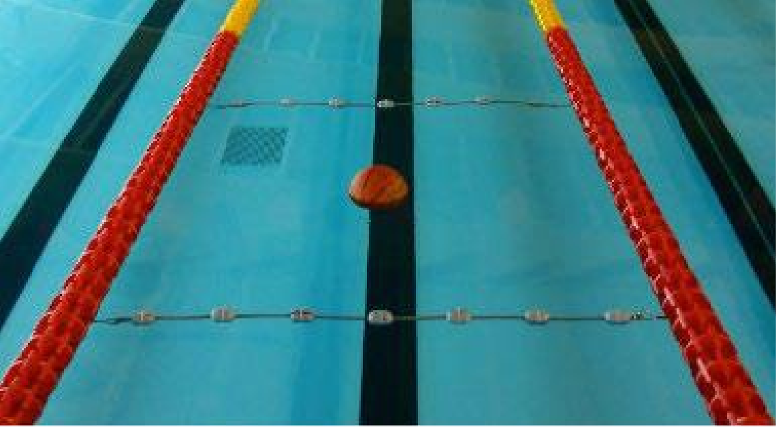
2.5 M
WORLD AQUATICS RULE | COMPLIANT | NONCOMPLIANT
PART 2, 15.11.2.1
PART 2, 15.11.2.2
PART 2, 15.11.2.3
PART 2, 15.11.2.4

LIGHTING

PART 2, 15.12.1 - At the Olympic Games and World Aquatics Events, light intensity over the whole pool must not be less than 1500 lux, measured from the pool deck.
PART 2, 15.12.2 - At all other competitions, light intensity over starting platforms and turning ends must not be less than 600 lux, measured from the pool deck
Lighting must be provided at the time of competition. Facilities need only attest that the ability to provide the described level of lighting Is possible. Lighting levels will be confirmed In the Event Certification at the time of the Event.
WORLD AQUATICS RULE | COMPLIANT | NONCOMPLIANT | N/A
PART 2, 15.12.1
PART 2, 15.12.2

LANE MARKINGS

PART 2, 15.13.1 - Lane markings must be of a dark contrasting colour, placed on the floor of the pool in the centre of each lane. Their width must be at minimum 0.2 metres and at maximum 0.3 metres. Their length must be 46.0 metres for 50m pools, or 21.0 metres for 25m pools.
PART 2, 15.13.2 - Each lane marking will be formed by a line in the centre of each lane that ends 2.0 metres from each end wall, with a distinctive cross line (perpendicular to the lane line) at each end that is 1.0 metre in length and the same width as the lane line. The distance between the centre points of each lane (and lane marking) must be 2.5 metres.
PART 2, 15.13.3 - Target lines of the same width as the lane lines must be placed on the end walls or on the touch panels, in the centre of each lane. The target lines will extend without interruption from the deck edge (curb), to the floor of the pool to a maximum of 3 metres. A cross line that is 0.5 metres in length will be placed in each lane (perpendicular to the target line) 0.3 metres below the water surface, measured at the centre point of the cross line.
PART 2, 15.13.4 - In 50m and 25m pools (except those constructed before 1 January 2006), a cross line that is 0.5 metres in length will be placed in each lane (perpendicular to the lane line) at the 15 metre-mark from each end of the pool. If there is a 15 metre-mark cross line, the 15-metre distance will be measured from the end of the pool to the centre point of the cross line.
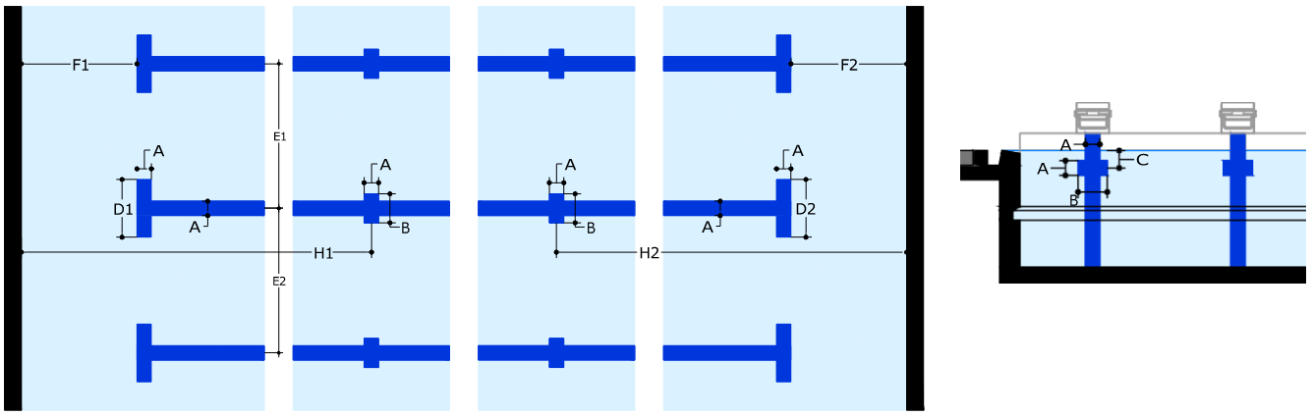

LANE NUMBER | A | B | C | D1/D2 | E1/E2 | F1/F2 | H1/H2
0
1
2
3
4
5
6
7
8
9

BULKHEADS

PART 2, 15.14.1 - When a bulkhead serves as an end wall, it must extend the full width of the course and present a solid, smooth, non-slippery, stable, vertical surface on which touch pads may be mounted extending not less than 0.8m below and 0.3m above the surface of the water, and must be free of potentially hazardous openings above or below the waterline that may be penetrated by an Athlete’s hands, feet, toes, or fingers. A bulkhead must be of a design that provides for the free movement of officials along its length without such movement creating any appreciable current or water turbulence.
WORLD AQUATICS RULE | YES | NO | N/A
BULKHEAD PRESENT |  |  | -
BULKHEAD COMPLIANT WITH PART 2, 15.14.1

POOL SEPARATION

PART 2, 15.15 - At the Olympic Games and the World Aquatics Championships, if the swimming pool and the diving well are located in the same area:
PART 2, 15.15.1 - If the pools were constructed on or after 1 January 2014, the pools must be separated by at least 8 metres (preferably 10 metres).
PART 2, 15.15.2 - If the pools were constructed before 1 January 2014, the pools must be separated by at least 5.0 metres.
WORLD AQUATICS RULE | YES | NO
MULTIPLE POOLS PRESENT
DATE OF POOL CONSTRUCTION
DISTANCE BETWEEN POOLS

TIMING REQUIREMENTS

PART 2, 15.16.4.1 - The minimum measurement of the touch panels must be 2.4 metres wide and 0.9 metre high, and the thickness must be 0.01 metres when the contact is closed (and the time is stopped).
PART 2, 15.16.4.2 - The touch panels will extend 0.3 metre above and 0.6 metre below the surface of the water. The equipment in each lane will be electronically connected independently, so it may be controlled and maintained individually. The surface of the panels must be of a bright colour and bear the end wall line markings described at Article 15.14 of this Part Two.
PART 2, 15.16.4.3 - The touch panels must be installed in a fixed position in the centre of the lanes. The panels may be portable, allowing the pool operator to remove them when there are no competitors.
PART 2, 15.16.4.5 - The markings on the panels must conform with and superimpose over the existing markings of the pool. The perimeter and edges of the panels will be defined by a 0.025 metre black border.
PART 2, 15.16.7 - The following accessories must be available for use in conjunction with the Automatic Officiating Equipment at the Olympic Games and the World Aquatics Championships:
PART 2, 15.16.7.1 - The spectator electronic display board must be at least 7.5 metres wide and 4.5 metres high.
PART 2, 15.16.7.2 - There must be an air-conditioned control room, with dimensions of at least 6.0 metres by 3.0 metres, located between 3.0 metres and 5.0 metres from the finish wall, with an unobstructed view of the finish wall at all times during the race. The Referee must have easy access to the control centre during the competition. At all other times the control room must be securable
PART 2, 15.16.8.1 - Timekeepers must have a clear and unobstructed view of the finishing end on the pool side from the Timing room (as shown in the below diagram). No sponsor panels or LED walls must be installed within (at minimum) 2 metres from the finish wall at the timing room side. The sponsor panels or LED walls must not exceed the 46 metres in length.
WORLD AQUATICS RULE | YES | NO | N/A
PART 2, 15.16.4.1 |  |  | -
PART 2, 15.16.4.2
PART 2, 15.16.4.3
PART 2, 15.16.4.5
PART 2, 15.16.7.1
PART 2, 15.16.7.2
PART 2, 15.16.8.1

ADDITONAL COMMENTS

This section is provided for additional comments:

SIGNATURES

BUILDING NAME:
SURVEYOR |  | SIGNATURE
POOL OPERATOR |  | SIGNATURE
ORGANIZING BODY |  | SIGNATURE
FEDERATION
POOL NUMBER |  | DATE

