

SWIMMING pool CERTIFICATION
world aquatics qualifying events

ORGANISING BODY
BUILDING NAME
OWNER

SURVEYOR, ENGINEER,
OR RESPONSIBLE PERSON
SIGNATURE
DATE

In force as from 1 APRIL 2026

MEASUREMENT CRITERIA

THE MEASUREMENTS SHALL BE DONE BY A CERTIFIED SURVEYOR, ENGINEER, OR OTHER QUALIFIED OFFICIAL APPOINTED OR APPROVED BY THE MEMBER IN THE COUNTRY IN WHICH THE VENUE IS LOCATED.

The surveying equipment shall be a LASER DISTANCE MEASURE.
REQUIRED Distance Measurement Accuracy: 2mm OVER 50M
preferred distance measurement accuracy: 1MM OVER 50M

THE APPOINTED SURVEYOR, ENGINEER, OR RESPONSIBLE PERSON SHALL ATTEST TO THE CALIBRATION OF THE MEASUREMENT DEVICE. THEY SHALL PROVIDE DOCUMENTATION SHOWING THAT THE CALIBRATION WAS PERFORMED WITHIN THE PAST YEAR.

All dimensions shall be measured using a mini prism or targets.
The measurements corresponding to PART 2, 15.1, 15.2, 15.8 shall be measured with the pool full of water. The water level can be lowered up to 5cm to avoid water reflection when measuring.
the length of the pool SHALL be measured at water level, in the centre of each lane.

MEASUREMENTS MUST BE TAKEN within forty-eight hours (48) prior to the competition with the touch panels installed.

LENGTH AND DIMENSIONAL TOLERANCES

This section shall apply to all lanes. The measurements must be taken following the set up for the event.
PART 2, 15.1.1.1 - If touch panels of Automatic Officiating Equipment are used at the starting end and/or at the turning end, the pool must be of such length that ensures the required distance of 50.000 metres between the two panels.
PART 2, 15.1.2.1 - If touch panels of Automatic Officiating Equipment are used at the starting end and/or at the turning end, the pool must be of such length that ensures the required distance of 25.000 metres between the two panels.
PART 2, 15.2.1.1 - The admissible tolerance in length in 50.000 metre swimming pools will be: +0.010 metres and -0.000 metres, when touch panels are installed.
PART 2, 15.2.2.1 - The admissible tolerance in 25.000 m swimming pools will be +0.010, and -0.000 metre when touch panels are installed.
These measurements should be certified by a surveyor or other qualified official, appointed or approved by the Member in the country in which the pool is located.
Distances between walls - Length shall be measured at water level in the centre of the lane.
POOL LENGTH | 25M | 50M
LANE NUMBER | LENGTH
0
1
2
3
4
5
6
7
8
9

WATER DEPTH

PART 2, 15.4.3 - At all other World Aquatics Events, the minimum pool depth is 1.0 metres, except that where starting blocks are used, the pool must have a minimum depth of 1.35 metres from between 1.0 metre from the end wall to at least 6.0 metres from the end wall.
Water Depth may be taken from construction drawings or previous survey.

LANE | WATER DEPTH 1M TO 6M FROM STARTING END [M] | MINIMUM WATER DEPTH [M]
0
1
2
3
4
5
6
7
8
9
MINIMUM POOL DEPTH [M]

STARTING PLATFORMS

Starting Platforms shall conform to PART 2, 15.8 in its entirety.
Product data sheets for the starting blocks used and photo documentation of the installation shall be submitted for validation.
WORLD AQUATICS RULE | COMPLIANT | NON-COMPLIANT
PART 2, 16.2.8
DOCUMENTATION SUBMITTED

WATER CONDITIONS

PART 2, 15.11.1 - The water temperature must be between 25º to 28º Celcius.
WORLD AQUATICS RULE | COMPLIANT | NONCOMPLIANT
PART 2, 15.11.1

PART 2, 15.11.2.1 - During competition, the surface level of the water in the pool must be constant, with no appreciable movement.
PART 2, 15.11.2.2 - On days of competition and training, in order to maintain the water level, preserve the transparency of water, and take into consideration the health regulations in force in most countries, inflow and outflow of water must be regulated as follows: 220 to 250 m3/h for 50m pools; 150 to 180 m3/h for 33.333m pools; [and] 120 to 150 m3/h for 25m pools.
PART 2, 15.11.2.3 - In daily use (i.e., outside of competition), inflow and outflow of water must follow the health regulations of the relevant country.
PART 2, 15.11.2.4 - At these water distribution turnover rates, there must be no appreciable current or turbulence created. In this context, “appreciable current” means water movement that can move a floating basketball (filled with 6 litres of water to obtain the right buoyancy) in one direction for more than 1.25 metres in 60 seconds.
PART 2, 15.11.2.5 - The practical way to test this is to install two floating lines crosswise in a swim lane to obtain a square with sides of 2.5 metres in length (see below image) and then to place the basketball in the central point of the square. If, after 60 seconds, the basketball does not touch any of the four lane ropes, the water movement test is successful.
PART 2, 15.11.2.6 - This test should be repeated eight times: at both ends of the pool in each of lanes 1, 3, 6, and 8. In each case, the basketball should be placed 5 metres from the end of the pool (whether using an end wall or a bulkhead).
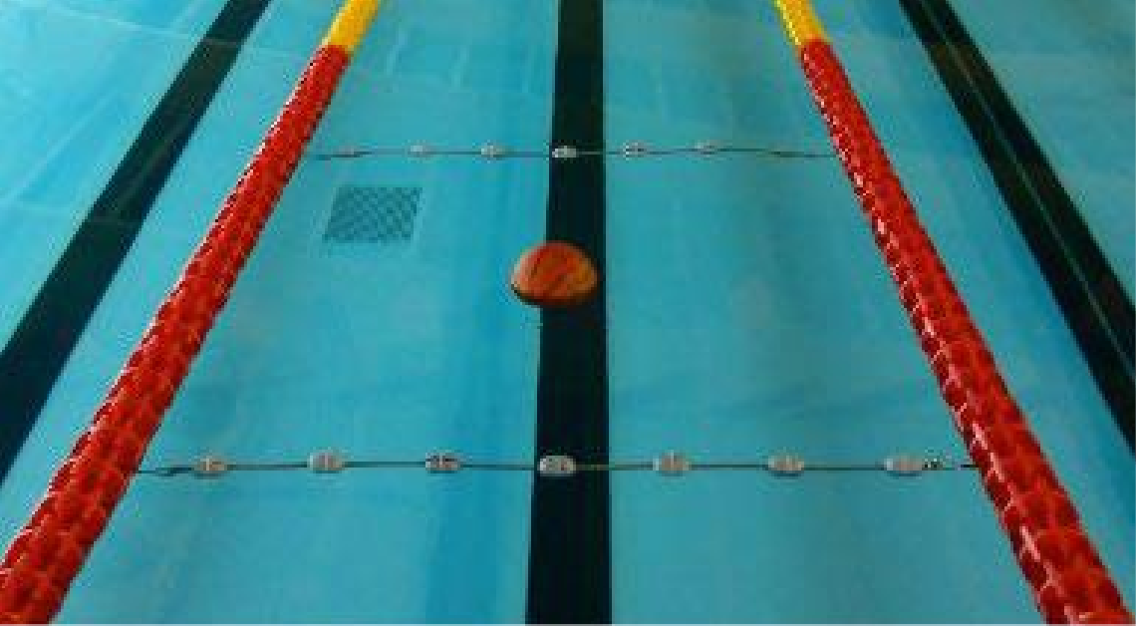
2.5 M
WORLD AQUATICS RULE | COMPLIANT | NONCOMPLIANT
PART 2, 15.11.2.1
PART 2, 15.11.2.2
PART 2, 15.11.2.3
PART 2, 15.11.2.4

SIGNATURES

BUILDING NAME
SURVEYOR |  | SIGNATURE
SURVEYOR |  | DATE
POOL OPERATOR |  | SIGNATURE
POOL OPERATOR |  | DATE
ORGANIZING BODY |  | SIGNATURE
ORGANIZING BODY |  | DATE
FEDERATION |  | SIGNATURE
FEDERATION |  | DATE
REVIEW STAMP

