

HIGH DIVING
POOL CERTIFICATION

ORGANIZING BODY
FACILITY NAME
OWNER
CONTRACTOR
DESIGN TEAM
DATE

WORLD AQUATICS
APPROVED BY
DATE
SIGNATURE

In force as from 1 APRIL 2026

Table of Contents
TYPE OF VENUE 4
GENERAL REQUIREMENTS 5
THE PLATFORMS 13
WATER CONDITIONS 16
JUDGES CONSIDERATIONS 17
ADDITIONAL COMMENTS 18
SIGNATURES 18

DRAWING SUBMITTAL REQUIREMENTS

As part of the facility pool certification document, the organizing body is required to submit drawings of the pool and associated competition areas for review in addendum with this document. These drawings must be in scale and reflect the as-built condition of the facility. The drawings must include:
A BUILDING PLAN VIEW, INCLUDING THE FULL DECK WIDTHS, JUDGES AREA, AND SPECTATOR SEATING AREAS;
A POOL PLAN VIEW WITH CORRESPONDING WATER DEPTHS;
A POOL LONGITUDINAL SECTION VIEW WITH CORRESPONDING WATER DEPTHS;
A POOL CROSS SECTION VIEW, SHOWING THE TOWER HEIGHTS, TOWER LOCATIONS, AND CORRESPONDING WATER DEPTHS.

MEASUREMENT CRITERIA

THE MEASUREMENTS SHALL BE DONE BY A CERTIFIED SURVEYOR, APPOINTED OR APPROVED BY THE MEMBER IN THE COUNTRY IN WHICH THE VENUE IS LOCATED.
THE SURVEYING EQUIPMENT SHALL BE A TOTAL STATION. THE MINIMUM REQUIREMENTS OF THE TOTAL STATION ARE THE FOLLOWING:
ANGLE MEASUREMENT ACCURACY HORIZONTAL AND VERTICAL: 1" (0.3 MGON)
DISTANCE MEASUREMENT ACCURACY: 1MM + 1.5PPM
THE SURVEYOR SHALL PROVIDE A CALIBRATION CERTIFICATE CONFIRMING THE MEASUREMENT QUALITY OF SURVEYING EQUIPMENT. THE CERTIFICATE SHALL HAVE A MAXIMUM VALIDITY OF 1 YEAR.
ALL DIMENSIONS SHALL BE MEASURED USING A MINI PRISM OR TARGETS.
HIGH DIVING TOWER MEASUREMENTS SHALL BE TAKEN WITH THE POOL, OR RELEVANT LANDING ZONE, FULL OF WATER.
HIGH DIVING POOL, OR RELEVANT LANDING ZONE, MEASUREMENTS SHALL BE TAKEN WITH THE POOL EMPTY OF WATER. NATURAL BODIES OF WATER ARE EXCLUDED.
THE WATER TEMPERATURE SHOULD BE NOT LESS THAN 18°C IN NATURAL WATER VENUES AND NOT LESS THAN 26°C DEGREES IN VENUES WITH AN ARTIFICIAL POOL.
THE HORIZONTALITY OF EACH PLATFORM EDGE SHALL BE MEASURED IN AT LEAST IN 3 POINTS. A TOLERANCE OF 1MM PER METRE IS ALLOWED, PROVIDING THAT ALL THE POINTS ARE COMPLYING WITH PART 5, 12.5.1 AND 12.5.2. THE HEIGHT OF EACH PLATFORM ABOVE THE WATER LEVEL MAY VARY BY PLUS 0.05M AND MINUS 0.00M FROM THE HEIGHTS PRESCRIBED IN THE RULES. IN NATURAL SURROUNDINGS (SEA, LAKES, RIVERS ETC.) HEIGHT TOLERANCE: ± 1M.
TEMPORARY PLATFORMS INTO NATURAL WATER WITH TIDES, THE PLATFORMS MUST BE CONSTRUCTED IN A WAY THAT DURING THE EXPECTED COMPETITION DAYS THE COMPETITION HEIGHTS ARE WITHIN THE TOLERANCES.

TYPE OF VENUE

The facility shall identify the type of platform structure, Type of landing zone, construction material (i.e. Concrete, Stainless Steel, etc.), and pool finish type (i.e. Paint, Plaster, Tile, Liner, etc.).
TYPE OF PLATFORM STRUCTURE | TOWER | BUILDING | CLIFF
TYPE OF LANDING ZONE | NATURAL WATER | PERMANENT  POOL | TEMPORARY  POOL
POOL CONSTRUCTION
POOL FINISH

GENERAL REQUIREMENTS

PART 5, 14.1.1 - High Diving should wherever possible take place in a controlled environment with purpose-built fabricated towers and pools for diving.
PART 5, 14.1.2 - Where purpose-built towers and pools are not used, High Diving may be performed from fabricated platforms on existing buildings or natural cliff faces into open water (sea, lakes or rivers etc.), subject to prior approval from World Aquatics.
PART 5, 14.1.3 - Wherever possible, the pool should be rectangular. Temporary round pools, or other pools in natural environments, may be used in special circumstances, subject to prior approval from World Aquatics and the Technical High Diving Committee.
WORLD AQUATICS RULE | COMPLIANT | NONCOMPLIANT
PART 5, 14.1.1
PART 5, 14.1.2
POOL SHAPE
PRIOR WORLD AQUATICS APPROVAL
PART 5, 14.1.3

PART 5, 14.1.4 - The dimensions for High Diving facilities, as set out in this Article 14 of this Part Five and in Appendices 2 and 3 must be observed, subject to Article 14.1.5 of this Part Five. Dimensions should be measured and referred to in metres.
PART 5, 14.1.5 - The dimensions for facilities at a High Diving event may be adjusted for a particular competition, where necessary in the location and circumstances, subject to prior consultation with and approval by the Bureau.
WORLD AQUATICS RULE | COMPLIANT | NONCOMPLIANT
PART 5, 14.1.5
PART 5, 14.1.6
PART 5, 14.1.3

This table must be completed for use with a rectangular pool to verify PART 5, 14.1.4. PART 5, Appendix 1 and PART 5, Appendix 2 have been included on the following pages for reference.
DIMENSION [M] | PLATFORM
DIMENSION [M] | P-3 | P-5 | P-7.5 | P-10 | P-15 |  | P-20 | P-21-26 | P-27
A - PLUMMET BACK TO POOL WALL
A/A - PLUMMET BACK TO PLATFORM
B - PLUMMET TO POOL WALL AT SIDE
C - PLUMMET TO ADJACENT PLUMMET
D - PLUMMET FORWARD TO POOL WALL
E - PLATFORM TO CEILING OR PLATFORM ABOVE
F - CLEAR OVERHEAD SIDE
G - CLEAR OVERHEAD FORWARD
H - DEPTH OF WATER AT PLUMMET
J - DISTANCE AHEAD OF PLUMMET AT DEPTH K
K - DEPTH AHEAD OF PLUMMET AT DISTANCE J
L - DISTANCE TO SIDE OF PLUMMET AT DEPTH M
M - DEPTH TO SIDE OF PLUMMET AT DISTANCE L
N - MAXIMUM SLOPE TO REDUCE DIMENSIONS BEYOND FULL REQUIREMENT FOR THE POOL DEPTH AND CEILING HEIGHT
MAXIMUM LANDING ZONE WIDTH
HANDRAIL MEASUREMENTS | COMPLIANT |  |  |  |  | NONCOMPLIANT

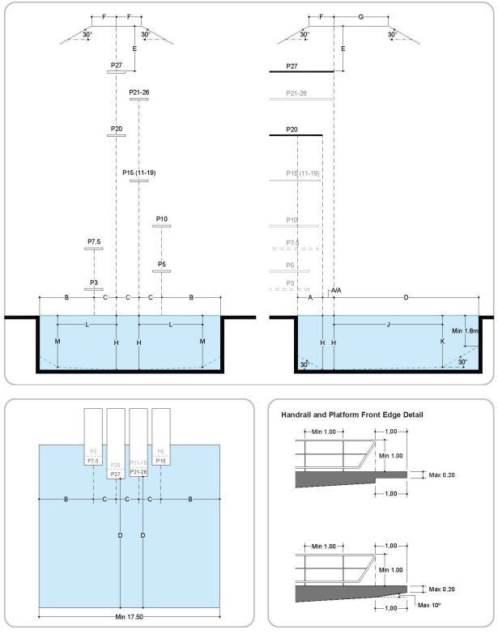
1. PART 5, APPENDIX 1

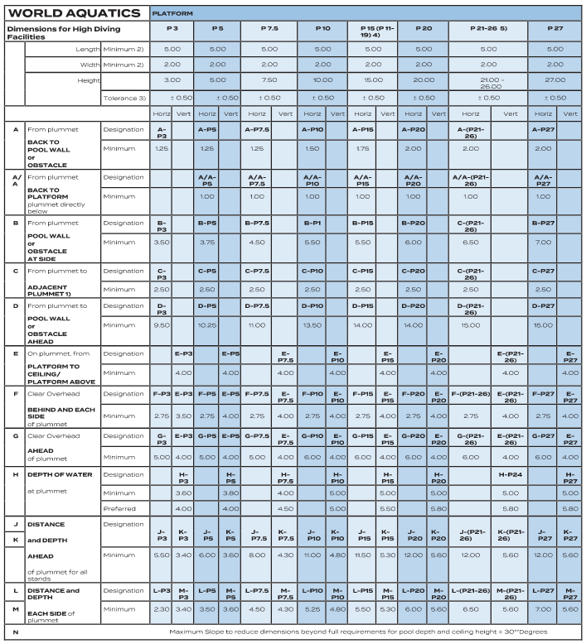
2. PART 5, APPENDIX 2
NOTES:
- The appropriate local authorities must certify that the following minimum requirements are observed.
- The side distance between platforms must not be less than 0.50 metres.
- For High Diving events other than World Aquatics Championships and World Cups the following minimum platform dimensions are accepted: length 2.0m / width 1.5m; adjacent platform distances between platforms to be adjusted accordingly with the respect of 0.50 metres distance between the platforms.
- In natural surroundings (sea, lakes, rivers etc.) height tolerance: ± 0.5 metres.
- 15 metres is an official height for Age Group A (17 - 19) and Group B (15 – 16) competitions and dimensions valid for all heights between 11 - 19 metres.
- The value for a 24 metre platform is valid for all heights between 21.00 - 26.00 metres.
This table must be completed for use with a circular pool to verify PART 5, 14.1.4. PART 5, Appendix 2 and PART 5, Appendix 3 have been included on the following pages for reference.
DIMENSION [M] | PLATFORM
DIMENSION [M] | P-3 | P-5 | P-7.5 | P-10 | P-15 |  | P-20 | P-21-26 | P-27
A - PLUMMET BACK TO POOL WALL
A/A - PLUMMET BACK TO PLATFORM
B - PLUMMET TO POOL WALL AT SIDE
C - PLUMMET TO ADJACENT PLUMMET
D - PLUMMET FORWARD TO POOL WALL
E - PLATFORM TO CEILING OR PLATFORM ABOVE
F - CLEAR OVERHEAD SIDE
G - CLEAR OVERHEAD FORWARD
H - DEPTH OF WATER AT PLUMMET
J - DISTANCE AHEAD OF PLUMMET AT DEPTH K
K - DEPTH AHEAD OF PLUMMET AT DISTANCE J
L - DISTANCE TO SIDE OF PLUMMET AT DEPTH M
M - DEPTH TO SIDE OF PLUMMET AT DISTANCE L
N - MAXIMUM SLOPE TO REDUCE DIMENSIONS BEYOND FULL REQUIREMENT FOR THE POOL DEPTH AND CEILING HEIGHT
MAXIMUM LANDING ZONE WIDTH
HANDRAIL MEASUREMENTS | COMPLIANT |  |  |  |  | NONCOMPLIANT

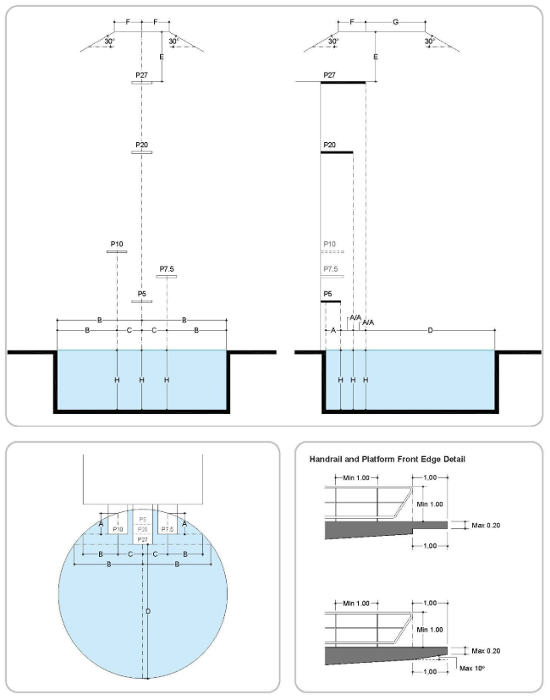
3. PART 5, APPENDIX 3
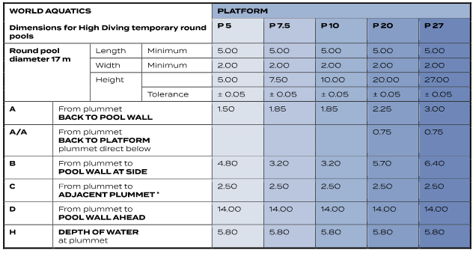
4. PART 5, APPENDIX 4
NOTES:
- The appropriate local authorities must certify that the following minimum requirements are observed.
- The side distance between platforms must not be less than 0.50 metre.
- As set out in Article 14.1.3, Temporary round pools, or other pools in natural environments, may only be used in special circumstances, subject to prior approval from World Aquatics and the Technical High Diving Committee.
- The same dimensions and configuration of the platforms may be achieved in a rectangular pool with the following dimensions: 14 x 17 metres.

PART 5, 14.1.6 - High Diving facilities are only for the use of expert Athletes, they are not suitable for public use. Management Committees, local authorities, venue managers and others with responsibility for High Diving facilities and/or equipment must ensure that security guards and/or lockable structures or gates are in place to prevent any unauthorised persons climbing or otherwise using the High Diving towers.
PART 5, 14.1.7 - All High Diving facilities and equipment must be inspected and approved by the World Aquatics Technical Delegate and a member of the Technical High Diving Committee no later than 120 days prior to the start date of the competition, to ensure compliance with the requirements in this Part Five. For the avoidance of doubt, this requirement applies to all facilities and equipment for each World Aquatics Event, including those held at newly constructed facilities (which, wherever possible, should seek prior approval from the World Aquatics Technical Committee or its delegate on the design of such new facilities).
WORLD AQUATICS RULE | COMPLIANT | NONCOMPLIANT
PART 5, 14.1.6
DATE OF INSPECTION
NAME OF INSPECTOR
PART 5, 14.1.7

THE PLATFORMS

PART 5, 14.2.1 - Each platform must be rigid and horizontal (parallel to the water’s surface).
PART 5, 14.2.2 - The dimensions of the platform for each platform height (including heights used in practice sessions) must be:
PLATFORM | REQUIRED WIDTH | REQUIRED LENGTH |  | MEASURED WIDTH [M] |  | MEASURED LENGTH [M]
P-3 (3M) | 2.00M  1.50M* | 5.00M  2.0M*
P-5 (5M) | 2.00M  1.50M* | 5.00M  2.0M*
P-7.5 (7.5M) | 2.00M  1.50M* | 5.00M  2.0M*
P-10 (10M) | 2.00M  1.50M* | 5.00M  2.0M*
P-15  (11M - 19M) | 2.00M  1.50M* | 5.00M  2.0M*
P-20 (20M) | 2.00M | 5.00M
P-21-26 (21M - 26M) | 2.00M  1.50M* | 5.00M  2.0M*
P-27 (27M) | 2.00M | 5.00M
*ACCEPTED FOR EVENTS OTHER THAN WORLD AQUATICS CHAMPIONSHIPS AND WORLD CUPS
WORLD AQUATICS RULE |  |  | COMPLIANT |  | NONCOMPLIANT
PART 5, 14.2.1
PART 5, 14.2.2

PART 5, 14.2.3 - The thickness of the front edge of the platform must not exceed 0.2 metres and may be vertical or inclined at an angle not greater than 10 degrees to the vertical inside the plummet line (which is a vertical line, perpendicular to the water’s surface, extending through the centre of the front edge of the platform).
PART 5, 14.2.3.1 - The entire surface of all platforms must be covered with slip-resistant material that must have a tread pattern that provides sufficient friction in wet and dry conditions such that the Athletes do not slip when performing dives in all directions.
PART 5, 14.2.3.2 - If a surface material which has not previously been approved by World Aquatics is proposed for use at a competition, a physical sample must be sent to the Technical High Diving Committee for testing and approval before it can be used.
PART 5, 14.2.3.3 - Terracotta is the preferred colour of the platform surface material. Black, white and blue coloured surface materials are not permitted.
PART 5, 14.2.3.4 - The colour of the carpet on the pool deck must not be blue. Grey is preferred.

WORLD AQUATICS RULE | COMPLIANT | NONCOMPLIANT
PART 5, 14.2.3
PART 5, 14.2.3.1
PART 5, 14.2.3.2
PART 5, 14.2.3.3
PART 5, 14.2.3.4

PART 5, 14.2.4 - The back and sides of each platform must be surrounded (on three sides) by handrails up to 1 metre from the edge of the platform with a minimum clearance of 1.8 metres between vertical pairs. The minimum height of those handrails must be 1 metre, and they must be accompanied by at least two horizontal crossbars placed outside the platform beginning 1 metre from the front edge of the platform.
WORLD AQUATICS RULE | COMPLIANT | NONCOMPLIANT
PART 5, 14.2.4

PART 5, 14.2.5 - Each platform must be accessible by suitable slip-resistant stairs (not ladders), and must also meet local building regulations and or health and safety standards that are applicable.
WORLD AQUATICS RULE | COMPLIANT | NONCOMPLIANT
PART 5, 14.2.5

PART 5, 14.2.6 - It is preferred that a platform is not constructed directly under any other platform, however in circumstances where this cannot be avoided then the dimensions must be as set out in Appendix 2.
WORLD AQUATICS RULE | COMPLIANT | NONCOMPLIANT
PART 5, 14.2.6

PART 5, 14.2.7 - The platform must be a concrete, steel or other rigid material construction as approved by World Aquatics:
PART 5, 14.2.7.1 - The longitude and latitude movement/oscillation allowance for the entire tower structure must be 2.7 cm (1/1000 from 27m).
PART 5, 14.2.7.2 - The maximum wind speed for the tower oscillation stability is 54km/hour (banners will affect stability).
PART 5, 14.2.7.3 - The downward flex at the diving end of the platform must not exceed 2-3mm and must be approved by the relevant local authority/authorities.

WORLD AQUATICS RULE | COMPLIANT | NONCOMPLIANT
PART 5, 14.2.7
PART 5, 14.2.7.1
PART 5, 14.2.7.2
PART 5, 14.2.7.3

PART 5, 14.2.8 - In addition to the other requirements set out in this Part Five, High Diving platforms designed and constructed after 31 December 2017 must also meet the minimum dimensions detailed in Appendix 2 and (if applicable) Appendix 4.
WORLD AQUATICS RULE | COMPLIANT | NONCOMPLIANT | N/A
PART 5, 14.2.8

PART 5, 14.2.9 - Where possible the platforms should face north in the northern hemisphere and south in the southern hemisphere.
WORLD AQUATICS RULE | COMPLIANT | NONCOMPLIANT | N/A
PART 5, 14.2.9

WATER CONDITIONS

PART 5, 14.2.10.1 - In open water venues, the water temperature must not be lower than 18 degrees Celsius.
PART 5, 14.2.10.2 - Wherever possible, the water temperature should be not less than 26 degrees Celsius when using an artificial pool.
WATER TEMPERTURE |  | ⁰C
WORLD AQUATICS RULE | COMPLIANT | NONCOMPLIANT | N/A
PART 5, 14.2.10.1
PART 5, 14.2.10.2

PART 5, 14.2.11 - A certificate of suitability for use of the venue must be issued by the appropriate local health and safety authorities. The certification must also confirm that the water quality is sufficient for human use (diving and swimming).
WORLD AQUATICS RULE | COMPLIANT | NONCOMPLIANT
PART 5, 14.2.11

PART 5, 12.1.3.5 - Surface agitation must be provided by a strong horizontal water spray and the scuba divers must also provide additional splash when necessary. The water spray must not be mounted higher than 1.50m above the water level. The water spray should be strong and provide foamy white water for better visibility for the athletes. The spray or the foam must be strong enough to cover the landing area.
WORLD AQUATICS RULE | COMPLIANT | NONCOMPLIANT
PART 5, 12.1.3.5

The facility shall include wind measuring devices so 14.2.13 can be considered at the time of competition.
 | YES | NO
MEASURING DEVICE INCLUDED

JUDGES CONSIDERATIONS

PART 5, 14.3.1 - The Judges must sit side by side in two lines on one side of the platform, with the sunlight to their back or above them. In indoor facilities and special circumstances, the Referee may decide that the Judges are placed on both sides of the platforms.
PART 5, 14.3.2 - 2 No Judge will be seated behind the front edge of the platform.
PART 5, 14.3.3 - The Judges must be seated at a distance between thirty (30) metres and forty (40) metres from the entry point of the platforms, and in a position elevated between three (3) and six (6) metres above the water level. Special local circumstances may influence the position of the Judges.
WATER TEMPERTURE |  | ⁰C
WORLD AQUATICS RULE | COMPLIANT | NONCOMPLIANT | N/A
PART 5, 14.3.1
PART 5, 14.3.2
PART 5, 14.3.3

ADDITONAL COMMENTS

This section is provided for additional comments:

SIGNATURES

BUILDING NAME
SURVEYOR |  | SIGNATURE
SURVEYOR |  | DATE
POOL OPERATOR |  | SIGNATURE
POOL OPERATOR |  | DATE
ORGANIZING BODY |  | SIGNATURE
ORGANIZING BODY |  | DATE
FEDERATION |  | SIGNATURE
FEDERATION |  | DATE
REVIEW STAMP

