

WATER POLO
EVENT CERTIFICATION

ORGANIZING BODY
BUILDING NAME
OWNER
CONTRACTOR
DESIGN TEAM
DATE

WORLD AQUATICS
APPROVED BY
DATE
SIGNATURE

In force as from 1 April 2026

MEASUREMENT CRITERIA

THE MEASUREMENTS must BE DONE BY A CERTIFIED SURVEYOR, APPOINTED OR APPROVED BY THE MEMBER IN THE COUNTRY IN WHICH THE VENUE IS LOCATED.

The surveying equipment must be a Total Station. The minimum requirements of the Total Station are the following:
Angle Measurement Accuracy HORIzONTAL and VERTICAL: 1" (0.3 mgon)
Distance Measurement Accuracy: 1mm + 1.5ppm

The surveyor must provide a Calibration Certificate confirming the measurement quality of surveying equipment. The certificate must have a maximum validity of 1 year.

All dimensions must be measured using a mini prism or targets.

measurements must be measured with the pool full of water.

The water temperature The water temperature must be between 25.0°C and 27.0°C PER PART 6, 20.2.7.

FIELD OF PLAY

PART 6, 20.2.3 - The dimensions of the Field of Play are also set out in the diagram at Appendix 1 to this Part Six. However, in the case of any conflict between that Appendix and this Article 20, this Article 20 will prevail.
WORLD AQUATICS RULE | COMPLIANT | NONCOMPLIANT
PART 6, 20.2.3

PART 6, 20.2 – General Requirements for the Field of Play:
20.2.1 - The limits of the Field of Play are the inner edges of the two (2) Goal Lines and the two (2) Side Lines.
20.2.2.1 - Length: the distance between the inner edge of the two (2) Goal Lines must be 25.00 metres.
20.2.2.2 - Width: the distance between the inner edge of the two (2) Side Lines must be 20.00 metres.
20.2.3 - The dimensions of the Field of Play are also set out in the diagram at Appendix 1 to this Part Six. However, in the case of any conflict between that Appendix and this Article 20, this Article 20 will prevail.
DIMENSION [M] | MEN/WOMEN
A1
A2
A3
A4
A5
B1
B2
B3
B4
B5
C1
C2
C3
D1
D2
D3

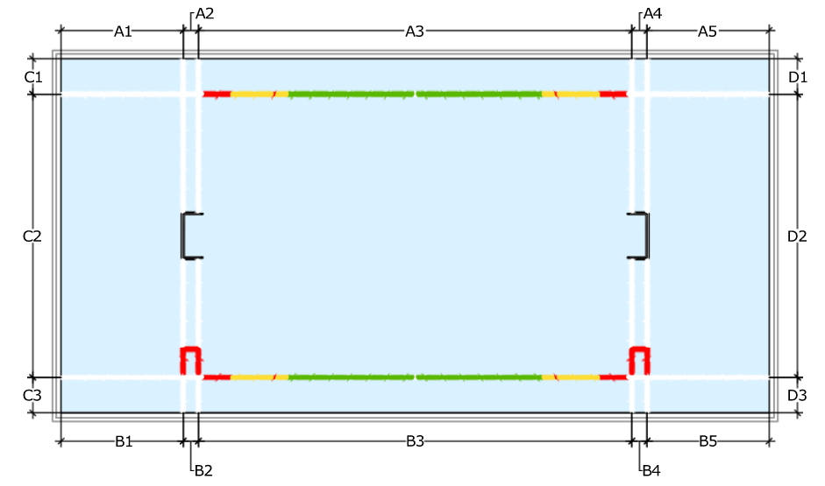
PART 6, 20.2.4 - The depth of the water inside the Field of Play will at no point be less than 2.00 metres.
WORLD AQUATICS RULE | COMPLIANT | NONCOMPLIANT
PART 6, 20.2.4

WATER TEMPERATURE

PART 6, 20.2.5 - The water temperature must be between 25.0°C and 27.0°C.
WORLD AQUATICS RULE | COMPLIANT | NONCOMPLIANT
PART 6, 20.2.5

LIGHT INTENSITY

PART 6, 20.8.2.2 - The light intensity shall not be less than 1500 lux. A lighting report shall be issued in addendum with this document.
 | YES |  | NO
LIGHTING REPORT ISSUED
WORLD AQUATICS RULE | COMPLIANT | NONCOMPLIANT |  | N/A
PART 6, 20.8.2.2

ADDITONAL COMMENTS

This section is provided for additional comments:

SIGNATURES

BUILDING NAME
SURVEYOR |  | SIGNATURE
SURVEYOR |  | DATE
POOL OPERATOR |  | SIGNATURE
POOL OPERATOR |  | DATE
ORGANIZING BODY |  | SIGNATURE
ORGANIZING BODY |  | DATE
FEDERATION |  | SIGNATURE
FEDERATION |  | DATE
REVIEW STAMP

