

SWIMMING
EVENT CERTIFICATION

ORGANIZING BODY
BUILDING NAME
OWNER
CONTRACTOR
DESIGN TEAM
DATE

WORLD AQUATICS
APPROVED BY
DATE
SIGNATURE

In force as from 1 APRIL 2026

Table of Contents
MEASUREMENT CRITERIA 3
LENGTH AND DIMENSIONAL TOLERANCES - 50M POOL WITH NO BULKHEAD 4
LENGTH AND DIMENSIONAL TOLERANCES - 50M POOL WITH BULKHEAD 5
LENGTH AND DIMENSIONAL TOLERANCES - 25M POOL WITH BULKHEAD 6
POOL WIDTH 7
WATER DEPTH 7
POOL LANES 9
POOL LANE ROPES 10
STARTING PLATFORMS 13
BACKSTROKE EQUIPMENT 14
WATER CONDITIONS 15
LIGHTING 16
LANE MARKINGS 17
ADDITONAL COMMENTS 18
SIGNATURES 18

MEASUREMENT CRITERIA

THE MEASUREMENTS SHALL BE DONE BY A CERTIFIED SURVEYOR, APPOINTED OR APPROVED BY THE MEMBER IN THE COUNTRY IN WHICH THE VENUE IS LOCATED.

The surveying equipment shall be a Total Station. The minimum requirements of the Total Station are the following:
Angle Measurement Accuracy HORIzONTAL and VERTICAL: 1" (0.3 mgon)
Distance Measurement Accuracy: 1mm + 1.5ppm

The surveyor shall provide a Calibration Certificate confirming the measurement quality of surveying equipment. The certificate SHALL have a maximum validity of 1 year.

All dimensions shall be measured using a mini prism or targets.
The measurements shall be measured with the pool full of water. The water level can be lowered up to 5cm FROM THE MEASUREMENT POINT to avoid water reflection when measuring.
The water temperature shall be 25º TO 28º Centigrade.
the length of the pool IN PART 2, 15.1 & 15.2 shall be measured in the centre of each lane WITH Automatic Officiating Equipment INSTALLED.

LENGTH AND DIMENSIONAL TOLERANCES - 50M POOL WITH NO BULKHEAD

This section shall apply to 50m pools with no bulkhead. For other pool types, please use the corresponding page.
PART 2, 15.1.1.1 - If touch panels of Automatic Officiating Equipment are used at the starting end and/or at the turning end, the pool must be of such length that ensures the required distance of 50.000 metres between the two panels.
PART 2, 15.2.1.1 - The admissible tolerance in length in 50.000 metre swimming pools will be: +0.010 metres and -0.000 metres, when touch panels are installed.
PART 2, 15.2.1.2 - For pools with touch panels of Automatic Officiating Equipment on both ends, the wall to wall distance will be at minimum 50.020 metres and at maximum 50.030 metres.
PART 2, 15.2.1.3 - The required length, subject to the permitted tolerances, must be consistent from 0.300 metre above to 0.800 metre below the water surface.
Distances between walls - Length shall be measured in the centre of the lane.
LANE NUMBER | 1.1A [M] | 1.1B [M]
0
1
2
3
4
5
6
7
8
9

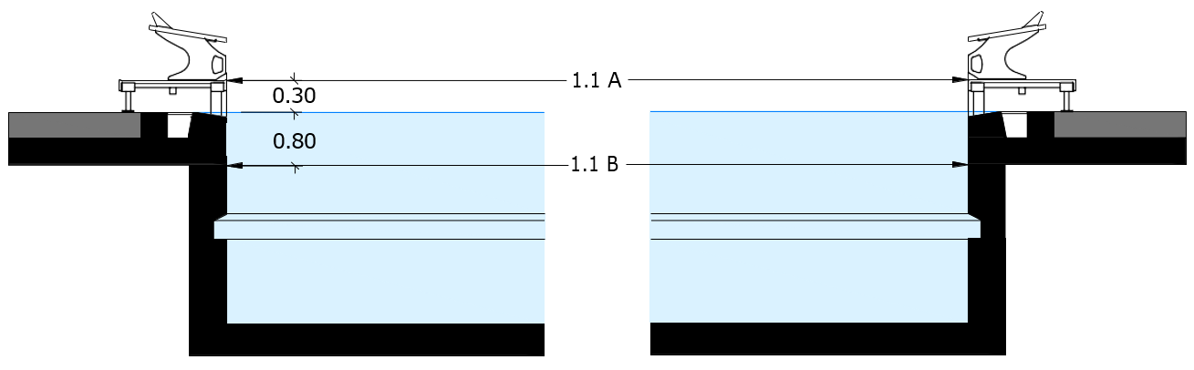

LENGTH AND DIMENSIONAL TOLERANCES - 50M POOL WITH BULKHEAD

This section shall apply to 50m pools with a bulkhead. For other pool types, please use the corresponding page.
PART 2, 15.1.1.1 - If touch panels of Automatic Officiating Equipment are used at the starting end and/or at the turning end, the pool must be of such length that ensures the required distance of 50.000 metres between the two panels.
PART 2, 15.2.1.1 - The admissible tolerance in length in 50.000 metre swimming pools will be: +0.010 metres and -0.000 metres, when touch panels are installed.
PART 2, 15.2.1.2 - For pools with touch panels of Automatic Officiating Equipment on both ends, the wall to wall distance will be at minimum 50.020 metres and at maximum 50.030 metres.
PART 2, 15.2.1.3 - The required length, subject to the permitted tolerances, must be consistent from 0.300 metre above to 0.800 metre below the water surface.
Distances between walls - Length shall be measured in the centre of the lane.
LANE NUMBER | 2.1A [M] | 2.1B [M]
0
1
2
3
4
5
6
7
8
9

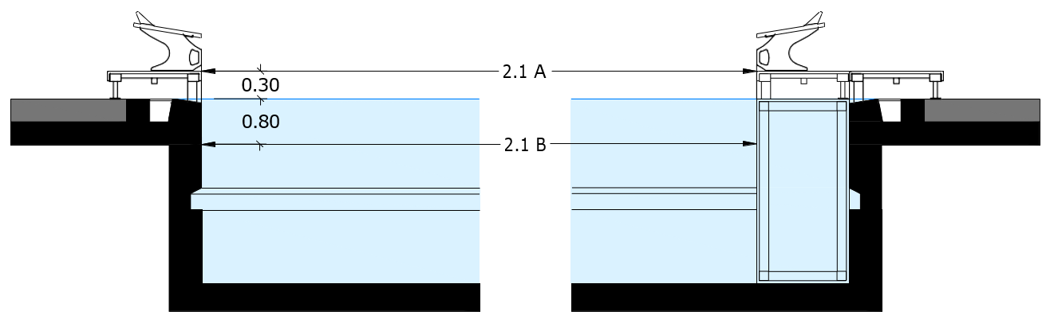

LENGTH AND DIMENSIONAL TOLERANCES - 25M POOL WITH BULKHEAD

This section shall apply to 25m pools with a bulkhead. For other pool types, please use the corresponding page.
PART 2, 15.1.2.1 - If touch panels of Automatic Officiating Equipment are used at the starting end and/or at the turning end, the pool must be of such length that ensures the required distance of 25.000 metres between the two panels.
PART 2, 15.2.2.1 - The admissible tolerance in 25.000 m swimming pools will be +0.010, and -0.000 metre when touch panels are installed.
PART 2, 15.2.2.2 - For pools with touch panels of Automatic Officiating Equipment on both ends the wall to wall distance will be at minimum 25.020 metres and at maximum 25.030 metres.
PART 2, 15.2.2.3 - For pools with touch panels of Automatic Officiating Equipment on one end the wall to wall distance will be at minimum 25.010 metres and at maximum 25.020 metres.
PART 2, 15.2.2.4 - The required length, subject to the permitted tolerances, must be consistent from 0.300 metre above to 0.800 metre below the water surface.
Distances between walls - Length shall be measured in the centre of the lane.
LANE NUMBER | 3.1A [M] | 3.1B [M] | 3.1C [M] | 3.1D [M]
0
1
2
3
4
5
6
7
8
9

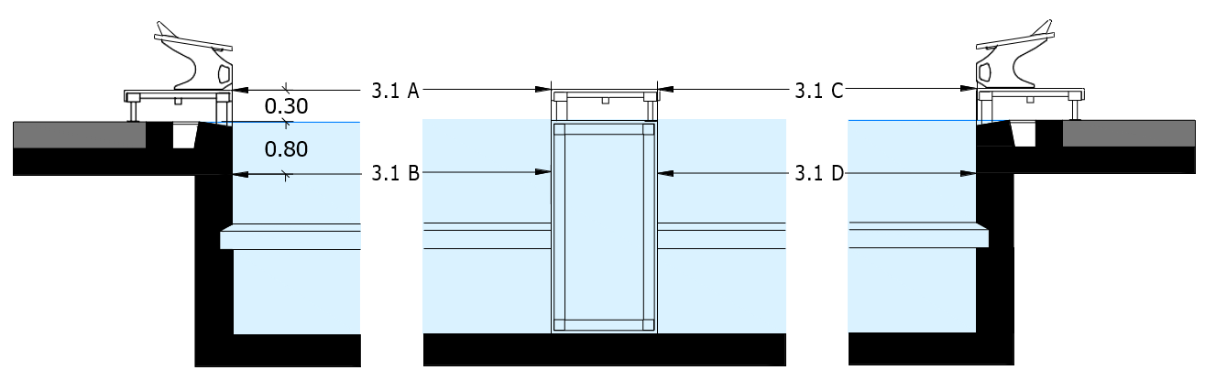

POOL WIDTH

PART 2, 15.3.1 - At the Olympic Games and the World Aquatics Championships, the minimum pool width for a permanent swimming pool is 25.000 metres and the minimum pool width for a temporary swimming pool is 26.000 metres.
PART 2, 15.3.2 - At all other competitions, there is no minimum width requirement.
If no damage or renovation has occurred since the submission of the Swimming Pool Certification, measurements from that document shall be accepted.
WORLD AQUATICS RULE | COMPLIANT | NONCOMPLIANT
PART 2, 15.3

WATER DEPTH

PART 2, 15.4.1 - At the Olympic Games and the World Aquatics Championships, the minimum pool depth is 2.5 metres.
PART 2, 15.4.2 - At the World Aquatics Swimming Championships (25m), the minimum pool depth is 2.0 metres (although 2.5 metres is recommended).
PART 2, 15.4.3 - At all other World Aquatics Events, the minimum pool depth is 1.0 metres, except that where starting blocks are used, the pool must have a minimum depth of 1.35 metres from between 1.0 metre from the end wall to at least 6.0 metres from the end wall.
If no damage or renovation has occurred since the submission of the Swimming Pool Certification, measurements from that document shall be accepted.
WORLD AQUATICS RULE | COMPLIANT | NONCOMPLIANT
PART 2, 15.4

POOL LANES

PART 2, 15.6.1 - At the Olympic Games, the pool must contain eight (8) lanes that are 2.5 metres in width, with a gap – separated by lane ropes – of 2.5 metres in width at the outer side of the first lane and the outer side of the last lane. See the diagram at Appendix 1. Ninth and tenth lanes may be used in exceptional circumstances with the approval of the Chair of the Technical Swimming Committee.
PART 2, 15.6.2 - At the World Aquatics Championships and the World Aquatics Swimming Championships (25m), the pool must contain ten (10) lanes
PART 2, 15.6.2.1 - For a permanent swimming pool, the middle eight (8) lanes must be 2.5 metres in width, and the outer two lanes must be 2.4 metres in width with a gap – separated by lane ropes – of at least 0.1 metres in width at the outer side of the first lane and the outer side of the last lane. See the diagrams at Appendix 2 and Appendix 8.
PART 2, 15.6.2.2 - For a temporary swimming pool, the ten (10) lanes must be 2.5 metres in width with a gap – separated by lane ropes – of at least 0.5 metres in width at the outer side of the first lane and the outer side of the last lane. See the diagrams at Appendix 3 and Appendix 9.
PART 2, 15.6.3 - At all other competitions, there is no minimum number of lanes. Lanes must be at least 2.5 metres wide, except for the first and last lanes, which must be at least 2.4 metres wide with a gap of at least 0.1 metres in width at the outer side of the first lane and the outer side of the last lane.
If no damage or renovation has occurred since the submission of the Swimming Pool Certification, measurements from that document shall be accepted.
WORLD AQUATICS RULE | COMPLIANT | NONCOMPLIANT
PART 2, 15.6

POOL LANE ROPES

PART 2, 15.7.1 - The main functions of a lane rope are to separate swimming lanes and reduce the pool waves. A lane rope should have properties to reduce the impact of a wave either continuing the other side of rope or bouncing back in the direction the wave came from.
PART 2, 15.7.2 - Lane ropes must extend the full length of the course and components not contributing to the rope’s wave reduction function, such as a tension spring and a take-up reel, must measure less than 200mm at each end of the rope.
PART 2, 15.7.5 - The take-up reel of the lane rope should require a tool to lock tensioning into position and to prevent unauthorised tampering. The lane rope must be equipped with a tension spring that can absorb sudden high point loads and a wire that can withstand a tensile force of 12 kN.
PART 2, 15.7.6.1 - The colour of the lane ropes should be as follows at the Olympic Games (see diagram at Appendix 1): Two (2) green ropes for lanes 1 and 8; Four (4) blue ropes for lanes 2, 3, 6, and 7; [and] Three (3) yellow ropes for lanes 4 and 5.
PART 2, 15.7.6.2 - The colour of the lane ropes should be as follows at the World Aquatics Championships and the World Aquatics Swimming Championships (25m) (see diagrams at Appendix 2, Appendix 3, Appendix 8, and Appendix 9): Two (2) green ropes for lanes 0 and 9; Six (6) blue ropes for lanes 1, 2, 3, 6, 7 and 8; [and] Three (3) yellow ropes for lanes 4 and 5.
PART 2, 15.7.6.3 - The colour of the lane ropes should be as follows at all other competitions (see diagrams at Appendix 1, Appendix 6, and Appendix 7): Two (2) green ropes for lanes 1 and 8; Four (4) blue ropes for lanes 2, 3, 6, and 7; [and] Three (3) yellow ropes for lanes 4 and 5.
PART 2, 15.7.6.4 - Variations in lane rope colour are permitted but the respective lanes must be distinguished by three (3) colours.
PART 2, 15.7.7 - Red floats attached to the lane ropes must extend for a distance of 5.0 metres from each end of the pool.
PART 2, 15.7.8 - There must not be more than one (1) lane rope between each lane. The lane ropes must be firmly stretched to a tension of between 1 kN and 1.2 kN.
PART 2, 15.7.9 - The floats on each lane rope at the 15 metre-mark from each end wall must be distinct in colour from the surrounding floats.
PART 2, 15.7.10 - In 50 metre pools the floats must be distinct (typically by contrasting colour) to mark 25 metres.
PART 2, 15.7.11 - Lane numbers of soft material may be positioned on the lane ropes at the starting end and the turning end of the pool.
Refer to table on next sheet.

WORLD AQUATICS RULE | COMPLIANT |  | NONCOMPLIANT
PART 2, 15.7.1
PART 2, 15.7.2
PART 2, 15.7.5
 | COMPLIANT | NONCOMPLIANT |  | N/A
PART 2, 15.7.6.1
PART 2, 15.7.6.2
PART 2, 15.7.6.3
 | VARIATION PRESENT |  | COLOURS USED
PART 2, 15.7.6.4
 | COMPLIANT |  | NONCOMPLIANT
PART 2, 15.7.7
PART 2, 15.7.8
PART 2, 15.7.9
PART 2, 15.7.10
PART 2, 15.7.11

STARTING PLATFORMS

PART 2, 15.8.1 - Starting platforms will be firm and provide no springing effect. The height of the top of the platform above the water surface will be between 0.5 metres and 0.75 metres. The starting platform surface area will be at least 0.5 metres by 0.5 metres, and will be covered with a slip-resistant material.
PART 2, 15.8.2 - The maximum permitted slope of the starting platform will be 10 degrees. The starting platform may have an adjustable setting back plate. The platform will be constructed so as to permit the gripping of the platform by the Athlete in the forward start at the front and the sides; it is recommended that, if the thickness of the starting platform exceeds 0.04 metres, grips of at least 0.1 metre in width on each side and at least 0.4 metres in width in the front be cut out to 0.03 metre from the surface of the platform.
PART 2, 15.8.3 - Handgrips for the forward start may be installed on the sides of the starting platforms. Handgrips for Backstroke starts will be placed between 0.3 metres and 0.6 metres above the water surface both horizontally and vertically. They will be parallel to the surface of the end wall and must not protrude beyond the end wall.
PART 2, 15.8.4 - A minimum depth of 1.35 metres, extending from 1.0 metre from the end wall to at least 6.0 metres from the end wall is required for pools with starting blocks.
PART 2, 15.8.5 - Electronic display boards may be installed under the blocks, but the display must not flash and the figures must not move during a Backstroke start.
PART 2, 15.8.6 - Each starting platform must be distinctly numbered on all four (4) sides, and the numbers must be clearly visible. It is recommended that lane number zero (0) be on the right-hand side when facing the course from the starting end, with exception of 50m events, which may start from the opposite end. Touch panels may be numbered on the top or bottom part.
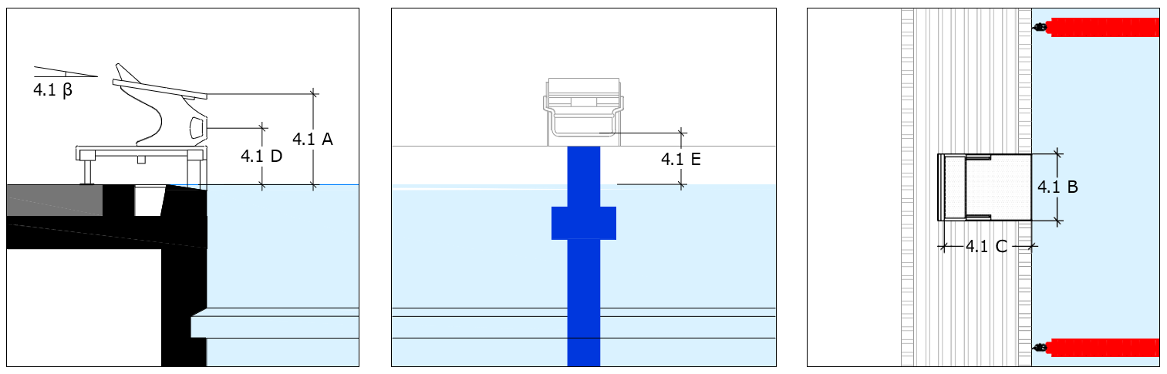
STARTING BLOCK DIMENSIONS | 4.1 A | 4.1 B | 4.1 C | 4.1 D | 4.1 E | 4.1 β
WORLD AQUATICS RULE |  |  | COMPLIANT |  | NONCOMPLIANT
PART 2, 15.8.1
PART 2, 15.8.2
PART 2, 15.8.3
PART 2, 15.8.4
PART 2, 15.8.5

BACKSTROKE EQUIPMENT

PART 2, 15.9.1 - Flagged ropes will be suspended across the pool, 1.8 metres above the water surface, from fixed standards placed 5.0 metres from each end wall. Distinctive marks must be placed on both sides of the pool and, where possible, on each lane rope, 15.0 metres from each end wall.
PART 2, 15.9.2 - Triangular flags of the following dimensions must be fixed to the ropes: 0.20 metres on the side attached to the rope and 0.40 metres on the other two sides. The distance between each flag must be 0.25 metres. If the flags contain or feature any printing or signage, that printing or signage must be approved in advance by World Aquatics.
PART 2, 15.10.1 - Backstroke ledges conforming to the specification set out below must be used.
PART 2, 15.10.1.1 - The ledge must be adjustable to 4 cm above or 4 cm below the water level and may not be used outside of this range.
PART 2, 15.10.1.2 - The ledge must be a minimum of 60 cm in length.
PART 2, 15.10.1.3 - The ledge must be 8 cm in height and 2 cm in width, with 10 degrees of slope.
WORLD AQUATICS RULE | COMPLIANT | NONCOMPLIANT
PART 2, 15.9.1
PART 2, 15.9.2
PART 2, 15.10.1

WATER CONDITIONS

PART 2, 15.11.1 - The water temperature must be between 25º to 28º Celcius.
WORLD AQUATICS RULE | COMPLIANT | NONCOMPLIANT
PART 2, 15.11.1

PART 2, 15.11.2.1 - During competition, the surface level of the water in the pool must be constant, with no appreciable movement.
PART 2, 15.11.2.2 - On days of competition and training, in order to maintain the water level, preserve the transparency of water, and take into consideration the health regulations in force in most countries, inflow and outflow of water must be regulated as follows: 220 to 250 m3/h for 50m pools; 150 to 180 m3/h for 33.333m pools; [and] 120 to 150 m3/h for 25m pools.
PART 2, 15.11.2.3 - In daily use (i.e., outside of competition), inflow and outflow of water must follow the health regulations of the relevant country.
PART 2, 15.11.2.4 - At these water distribution turnover rates, there must be no appreciable current or turbulence created. In this context, “appreciable current” means water movement that can move a floating basketball (filled with 6 litres of water to obtain the right buoyancy) in one direction for more than 1.25 metres in 60 seconds.
PART 2, 15.11.2.5 - The practical way to test this is to install two floating lines crosswise in a swim lane to obtain a square with sides of 2.5 metres in length (see below image) and then to place the basketball in the central point of the square. If, after 60 seconds, the basketball does not touch any of the four lane ropes, the water movement test is successful.
PART 2, 15.11.2.6 - This test should be repeated eight times: at both ends of the pool in each of lanes 1, 3, 6, and 8. In each case, the basketball should be placed 5 metres from the end of the pool (whether using an end wall or a bulkhead).
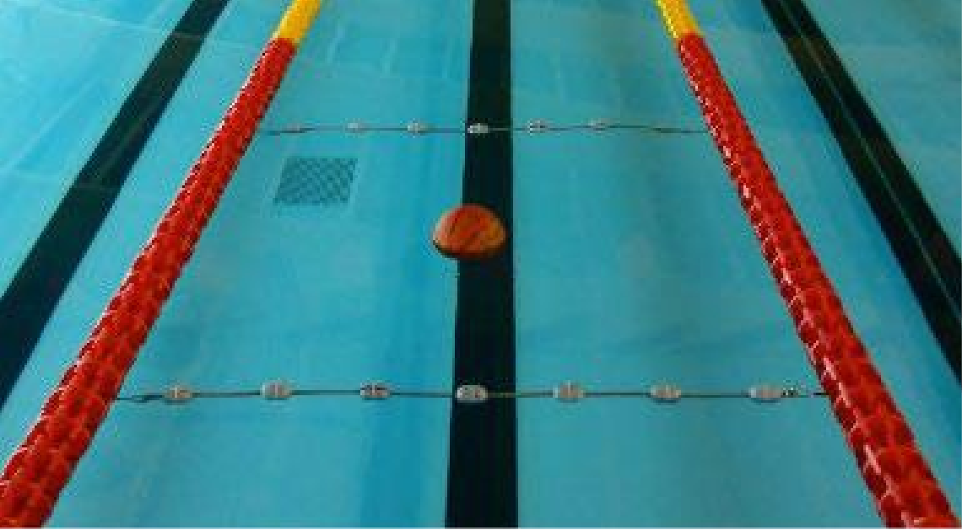
2.5 M
WORLD AQUATICS RULE | COMPLIANT | NONCOMPLIANT
PART 2, 15.11.2.1
PART 2, 15.11.2.2
PART 2, 15.11.2.3
PART 2, 15.11.2.4

LIGHTING

PART 2, 15.12.1 - At the Olympic Games and World Aquatics Events, light intensity over the whole pool must not be less than 1500 lux, measured from the pool deck.
PART 2, 15.12.2 - At all other competitions, light intensity over starting platforms and turning ends must not be less than 600 lux, measured from the pool deck
 | YES |  | NO
LIGHTING REPORT ISSUED
WORLD AQUATICS RULE | COMPLIANT | NONCOMPLIANT |  | N/A
PART 2, 15.12.1
PART 2, 15.12.2

LANE MARKINGS

PART 2, 15.13.1 - Lane markings must be of a dark contrasting colour, placed on the floor of the pool in the centre of each lane. Their width must be at minimum 0.2 metres and at maximum 0.3 metres. Their length must be 46.0 metres for 50m pools, or 21.0 metres for 25m pools.
PART 2, 15.13.2 - Each lane marking will be formed by a line in the centre of each lane that ends 2.0 metres from each end wall, with a distinctive cross line (perpendicular to the lane line) at each end that is 1.0 metre in length and the same width as the lane line. The distance between the centre points of each lane (and lane marking) must be 2.5 metres.
PART 2, 15.13.3 - Target lines of the same width as the lane lines must be placed on the end walls or on the touch panels, in the centre of each lane. The target lines will extend without interruption from the deck edge (curb), to the floor of the pool to a maximum of 3 metres. A cross line that is 0.5 metres in length will be placed in each lane (perpendicular to the target line) 0.3 metres below the water surface, measured at the centre point of the cross line.
PART 2, 15.13.4 - In 50m and 25m pools (except those constructed before 1 January 2006), a cross line that is 0.5 metres in length will be placed in each lane (perpendicular to the lane line) at the 15 metre-mark from each end of the pool. If there is a 15 metre-mark cross line, the 15-metre distance will be measured from the end of the pool to the centre point of the cross line.
If no damage or renovation has occurred since the submission of the Swimming Pool Certification, measurements from that document shall be accepted.
WORLD AQUATICS RULE | COMPLIANT | NONCOMPLIANT
PART 2, 15.13

ADDITONAL COMMENTS

This section is provided for additional comments:

SIGNATURES

BUILDING NAME
SURVEYOR |  | SIGNATURE
SURVEYOR |  | DATE
POOL OPERATOR |  | SIGNATURE
POOL OPERATOR |  | DATE
ORGANIZING BODY |  | SIGNATURE
ORGANIZING BODY |  | DATE
FEDERATION |  | SIGNATURE
FEDERATION |  | DATE
REVIEW STAMP

