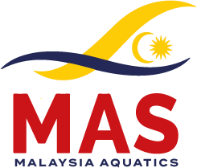 | 4th MALAYSIA OPEN DIVING CHAMPIONSHIP 2026.  *World Aquatics Recognised Event*  30th October – 1st November 2026 | 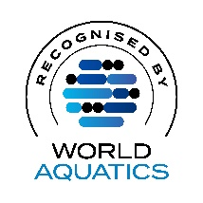

HOTEL RESERVATION FORM
(Please return by 10th October 2026)

1 | Country / Federation:
2 | Contact Person:
3 | Telephone Number:
4 | E-mail:

ROOM NO | NAME | SINGLE / DOUBLE | CHECK-IN | CHECK-OUT
1
2
3
4
5
6
7
8
9
10

Return to: Mr Low Siak San, Andy
Tel No:- +6 016 220 8 330

Email: secgen@malaysiaaquatics.org, Cc : kennee1983@gmail.com

Date :-__________________ _____________________________ ______________
(PRESIDENT / SECRETARY GENERAL) FEDERATION STAMP

